

Market Leap
User’s Guide

Copyright © 2007 by Health Quest, Inc
mARKET lEAP MANUAL
TABLE OF CONTENTS

Part I 5
Program Icons 5
System Database 5
Compact/Repair Database 5
Market Leap Icon 6
Market Leap Help 6
Starting Up 6
Daily Ticklers 7
Contact Tickler 7
Referral Tickler 8
Part II 9
Menus 9
Buttons 9
Main Menu 9
Form Color Selections 11
Part III 12
Contact Management Menu 12
Client Contact Information 12
Contact Entry 20
Add A Source 23
Tickler Review 29
Contact Review 30
Referrals 31
Add A Source 33
Lost Tickler Report 37
Room Availability 38
Waiting List 39
Label Options 41
Contact Labels 42
Referral Labels 42
Resident Labels 44
Part IV 46
Market Analysis Menu 46
Marketing Graphs 47
Average Lease-Ins/Lease-Outs 48
Average New Contacts 49
Contact Activity By Standing 50
Lease-Ins/Lease-Outs 51
Market Activity By Contact Type 52
Monthly Census Count 53
Monthly Market/Contact Activity 54
New Referrals By Referral Type 56
Reason For Not Coming 57
Referral Activity by Contact Type 58
Total Contact/Market Activity 59
Total Referral/Referral Contact Activity 61
Lease and Lead Reports 62
Contact/Referral Activity Count 64
Cost Per Lead and Lease 65
General Contact Info 66
Sources: Leads and Leases By Date Range 66
Marketer New Contacts/Market Activity 67
Referral Contacts Detail 68
Time To Close Lease By Resident 69
Marketing Budget Report 70
Demographic Reports 71
Demographic Client Contact Review 72
Demographic Information 73
Discharge Reports 74
Resident Discharge Information 74
Discharge Breakout 75
Part V 77
Resident Tracking Menu 77
Lease Update 77
Lease Change Options 81
Adding Lease Changes 81
Edit Lease Change 82
Resident Lease Change 84
Leave Of Absence 84
Resident Face Sheet 86
Resident Discharge Options 86
Occupancy Reports 90
Marketing Status Report 90
Occupancy Status Report 91
Occupancy Status Detail 93
Census 94
Resident Billing Report 96
Lease Changes Report 98
Lease Change Review 98
Meal Seating Assignments 100
PART VI. 102
Facility Options Menu 102
Software Options 102
Contact Fields 104
Resident Lease Field Options 105
Resident Lease Fields 106
Employee Information 107
Employee Census 109
Room Plan 110
Meal Seating Setup 111
Security Options 112
Add New User 112
Delete User 113
Clear User Password 113
Change User Password 114
Set Object Permissions 115
Options Menus 116
Advanced Options 116
Sort Options 117
Custom Options 118
TABLE OF EXHIBITS 119

Part I

Program Icons

During Market Leap installation, the program creates a three icon group which helps manage your new program. Double clicking on an icon carries out the instructions associated with that icon. For example, double clicking on the Market Leap icon will open Market Leap. The program group contains three icons Market Leap, Compact/Repair Database, and Market Leap Help icons.

System Database
A system database is a database file, which contains the security and system options for the marketing program. This file is usually called “system.mdw”.

Compact/Repair Database
Over time, as the user makes changes to the program, file storage can become fragmented. Compacting the program repairs the program making the database program smaller and often results in improved performance. For these reasons, it’s important to compact your program periodically. Sometimes, if there is a power failure, program crash, or the user simply turns off the computer without exiting properly, the program database can become corrupted. If the database becomes corrupted enough, the users will not bill able to access the program. Double clicking on the Compact/Repair Main Data compacts and repairs the marketing data, while the Compact/Repair Market Leap compacts and repairs the data manipulation objects. (Typically, it’s the data, which is most likely to become fragmented and/or corrupted.)

Market Leap Icon
Double clicking this icon opens the Market Leap program. Before entering the main menu, you must supply your “NAME” and “PASSWORD”; and then click OK. Remember that your password is case sensitive; if your password is in uppercase letters, you must key it in that way.

Market Leap Help
Double clicking this icon will display the Help Contents of the resident care on-line help file. Within the program, this help file is context sensitive and can be accessed by selecting the F1 key on the keyboard at any time. (Context sensitive help opens the help file to the currently selected topic.) The Market Leap help file provides an easy way to discover how different pieces of the Market Leap program work. Clicking on a highlighted, underlined word or phrase will jump you to that particular topic. You can use the SEARCH feature to search for a particular topic for information. The BACK button sends the user back to the last topic he/she accessed in the current help session. The History button displays a list of all topics viewed in the current help session in the order accessed. To jump back to the Help Contents, click on the Contents. You can print a topic by using the File pull down menu, or learn how to use on-line help and its features by using the help menu. Click the CLOSE button to exit help.

Starting Up
All computers will be equipped with surge suppressers. The monitor and the CPU should be left in the "ON" position at all times; power should be turned on and off from the surge suppresser switch. The Turbo feature located on the CPU should always be activated; there is never a need to disengage it. If during your use there is a network failure and the computer stops responding, simply hold down the Ctrl, Alt, and Delete buttons simultaneously. If this fails to reboot your computer, press the Reset button on the CPU and initiate the sign-on procedure.

Sign-on by supplying the correct password and clicking "OK." Move the cursor on top of the MARKETING icon and double-click. You will now need to supply your "NAME" and "PASSWORD;" click OK. Remember that your password is case sensitive; if your password is in uppercase letters, you must key it in that way.

When the hourglass appears, it is a sign that the computer is processing a series of instructions. Do not click the mouse or press any keys while the hourglass is running; the computer will remember these entries and attempt to execute them. The Contact Tickler and Referral Tickler forms will open.

Daily Ticklers

Contact Tickler
If contact information has already been entered in to your database, you will likely encounter today's leads that need to be followed up when you first start-up the program. A copy of the Contact Tickler form should be printed for each marketing associate at the beginning of the workday. This form will provide the marketing associate with a list of people to contact for the day. Click the PRINT button to print the tickler.
The pre-arranged follow-up type will dictate what kind of action is to be taken. From the form, the marketer can easily see who the contact is (‘Contact Name’), who the potential resident is (‘Resident’), how the contact is related to the resident (‘Relationship’), what the contact's phone number is ("Telephone"), and which marketing associate is responsible for the contact record (‘Marketer’). Marking an ‘X’ in the ‘Open to Client Contact Information’ box opens the “Client Contact Information” form to the potential resident record of the selected contact tickler record. Close “Client Contact Information” and you will return to the Contact Tickler. While this box is “X”ed, selecting the desired tickler record will open to the corresponding “Client Contact Information” record. This feature will allow you to move easily between the two forms, making information review and update a more efficient process.

Exhibit 1: Contact Tickler Form

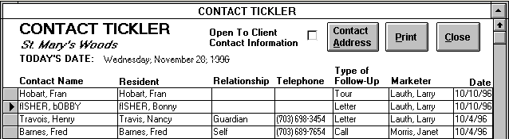

If written correspondence is necessary, the marketing associate can click CONTACT ADDRESS to view the full address of the selected contact. A contact is selected by clicking the gray button to the left of the desired contact’s name. To view the work telephone number of the contact, also use the CONTACT ADDRESS feature. Return to "Contact Tickler" by clicking the CLOSE button. The Contact Tickler form can be closed by clicking its CLOSE button; transferring you to the Referral Tickler. The “Contact Tickler” allows the use of the Advanced Options Menu. (For further explanation see Advance Options in the Menus Options section.)

Referral Tickler
If there are referrals to be tickled for the day, a copy of the Referral Tickler form should be printed for each marketing associate at the beginning of the workday. Use the PRINT button to produce the tickler. The pre-arranged follow-up type will dictate what kind of action is to be taken. From the form, the marketer can easily see who the referral is (‘Referral Name’), who the employer is (‘Company/ Agency Name’), and what the referral's phone number is (‘Telephone’). Marking an ‘X’ in the ‘Open to Referrals’ box opens the “Referrals” form to the potential resident record of the selected contact tickler record. Close “Referrals” and you will return to the Referral Tickler. While this box is “X”ed, selecting the desired tickler record will open to the corresponding “Referrals” record.

Exhibit 2: Referral Tickler

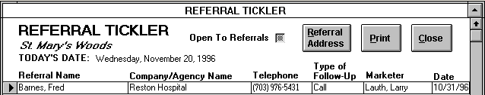

If written correspondence is necessary, the marketing associate can click REFERRAL ADDRESS to view the full address. Address information includes the referral contact name as well as the categories ‘Job Title’ and ‘Company Agency Name.’ The desired referral contact can be selected by clicking the gray button to the left of the referral name.

Exhibit 3: Referral Address
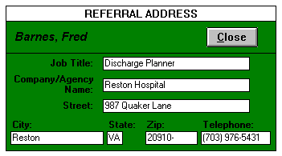

Click the CLOSE button to return to "Referral Tickler." Click the “Referral Tickler” CLOSE button to return to the Main Menu. The Referral Tickler form allows the use of the Advanced Options Menu.

Part II

Menus
There are four Market Leap menus. Each menu contains labeled buttons that enable you to open the forms you need. All the buttons in this program are simple to use: by moving the mouse, put the arrow over the button and click once.

Buttons
Exhibit 4: Buttons



Main Menu
Through the “Main Menu,” you can EXIT MARKET LEAP, enter the Market Leap Menus, and set form colors. Click the any of the three menu buttons, CONTACT MANAGEMENT MENU, MARKET ANALYSIS MENU, or RESIDENT TRACKING MENU to access the corresponding menu and its features. Those users belonging to the Marketing Coordinators group may access the “Facility Options Menu” by clicking on the FACILITY OPTIONS MENU button. Click on the FORM COLOR SELECTION button to set form colors.

Exhibit 5: Main Menu

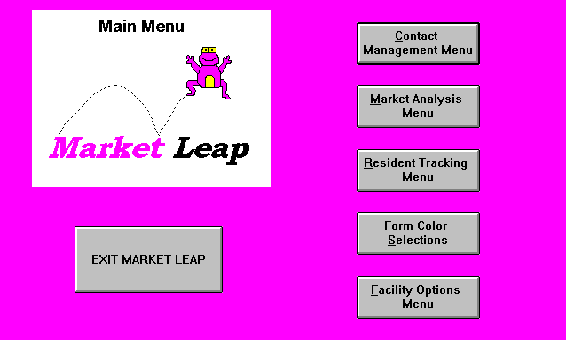

Form Color Selections
The FORM COLOR SELECTIONS button opens “Form Colors” which allows the marketing associate to set the background color of certain forms and menus used throughout Market Leap. These forms and menus are listed in the column ‘Form Name.’ To set the form color, simply highlight the form you wish to format and choose a color from the color bar. The color name will appear next to the form name under the column ‘Color.’ You may change form colors as often as you like. Click on the CLOSE button to close the form and return to the “Main Menu.”

Exhibit 6: Form Color Selections

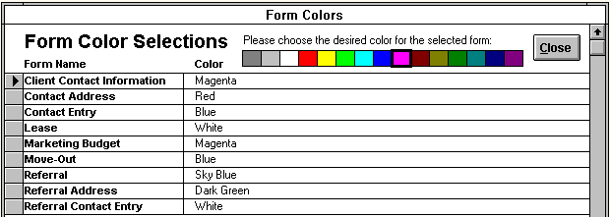

Part III

Contact Management Menu

Exhibit 7: Contact Management Menu

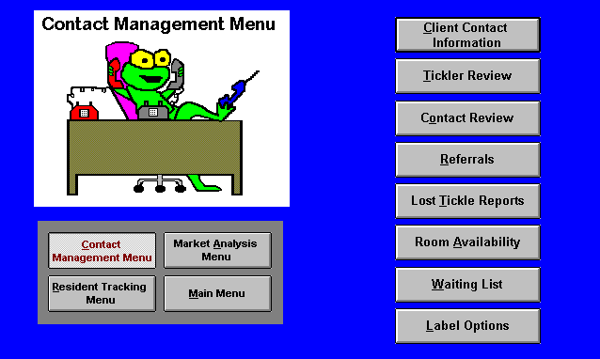

Client Contact Information
The purpose of this form is to collect data about a potential resident. Only one record is needed per potential resident. If you do not add a new resident, then he/she will not appear in any of your reports or forms, so this process is crucial.

When a marketing associate enters information on this form, she should first check to see if the potential resident is already part of the database. A search can be run by scrolling through the residents' names under the heading ‘Select the resident name to find;’ this feature is found at the bottom of the form. If you are more familiar with the contact's name, the search can be run by scrolling through the contacts' names under the heading ‘Select the contact name to find;’ this feature is also found at the bottom of the form. These two searches can be executed by first clicking the underlined arrow on the right side of the boxes and then using the up and down arrows to scroll through the alphabetized list of names. As the list of names may be very long, there is a useful short cut: First click the underlined arrow on the right side of the box and begin typing the name you are looking for (last name, first name). Once the search box locates the appropriate person, either click the person’s name from the list or press enter. To update these search lists to include any new records you have added since the form has been opened, click on the SEARCH UPDATE button.

Exhibit 8: Client Contact Information

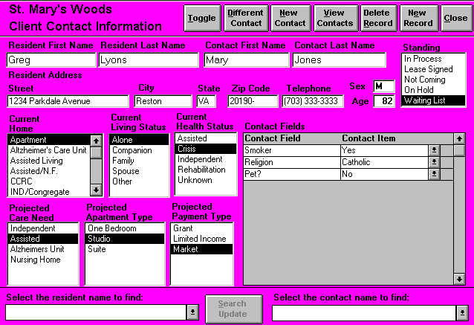

When the resident is already part of the database, the resident's name can be found by scrolling through the list. Once the name is found, the name should be clicked to retrieve the record. You will now see all the data that has previously been entered regarding the resident. A review of this record will provide you with the most recent information about the potential resident's address, phone number, age, gender, health status, home, desired type of accommodations, and most importantly, the standing of the resident. This form should only be kept current up to the time that the lease is signed. For example, it will be useful to know the age of the potential resident; but it is not necessary to know the age of an actual resident. The resident's birthday will be recorded in the “Lease” form. Therefore, once the lease is signed, information such as age or payment type should not be altered on the “Client Contact Information” form. If you need to add a potential resident and contact to the database click the NEW RECORD button. This feature will supply you with a new, blank record. You can move among all of these fields by using the enter key, the tab key, or the mouse.

Fields

Resident first name- Key in the resident's first name.

Resident last name- Key in the resident's surname.

Contact first name- Key in the contact's first name.

Contact last name- Key in the contact's surname.

Resident address- Enter the potential resident's current street address.

City- Enter the city where the potential resident lives.

State- Enter the state where the potential resident lives.

Zip code- Enter the five digit zip code belonging to the potential resident's address.

Telephone- Enter the area code and phone number of the potential resident.

Age- Enter the potential resident's age.

Sex- Enter an "F" if the potential resident is female; an "M" if he is male.

Along with the resident and contact names, standing is supremely important. Consider that the standing you choose will determine who will remain on the mailing list, who will receive a quarterly newsletter, how the waiting list will be used in an equitable manner, and how the marketing status report will reflect the work you have done. Each potential resident record can only have one standing at one time.

Standing:

In Process- The user can project a lease start date. Selecting this choice will require you to enter the appropriate date in the ‘Projected Lease Start Date’ field.

Lease Signed- Lease signed and move-in date set. Choosing this option will require you to complete the “Lease” form, thus creating a current resident. See the instructions under the heading “Lease Update.”

Not Coming- Choose this when the contact has informed you that the potential resident will not be moving to your property. Or choose this when you have determined that a potential resident will not be moving to your property. Keep in mind that this choice will require completion of the “Reason For Not Coming” form. If a potential resident’s standing is ‘Not Coming,’ clicking ‘Not Coming’ again will allow you to edit the potential resident’s not coming record.

Exhibit 9: Reason For Not Coming Form

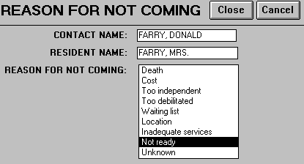

Select the reason that the resident will not be coming to your property:

Death- The potential resident died.

Cost- The potential resident has decided against your property because of its cost.

Too independent- The potential resident is too independent to live in your facility.

Too debilitated- The potential resident requires a level of care beyond your facility's capacity .

Waiting list- The potential resident decided against your property because she desires an immediate placement.

Location- The potential resident decided against your property because of its location.

Inadequate services- The potential resident decided against your property because of the services available.

Not ready- The potential resident did not sign a lease because she was not ready.

Unknown- The reason for not coming is not known.

Exit this form by clicking the CLOSE button. You will now be returned to the "Client Contact Information" form.
“Standing” Continued:
On Hold- No projected lease signing date. The contact remains on the mailing list. Tickle for these leads will probably be 1-180 days.

Waiting List- The decision has been made to move to your property. The potential resident is waiting for something that is currently unavailable (i.e., specific apartment type). These records will not be counted as “hot leads," but rather in a separate waiting list. When you select this option, you will need to complete the "Waiting List" form that appears on your screen. The potential resident's name, the contact name, and today's date will automatically be completed on the form. You need to select what the potential resident is ‘Waiting For:’

Special Income Program - The potential resident wants to participate in a Special Income Program.

Specific floor - The potential resident is interested in a room on a specific floor in your building.

Specific room type - Choose this option if the resident is waiting for a one bedroom, for example.

Combination - For example, choose this option if the resident is waiting for a one bedroom on the third floor.

Other - Choose this option when none of the above correctly describes what the potential resident's is waiting for.

Exhibit 10: Waiting List Form

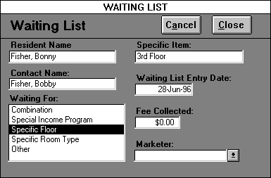

Now complete the ‘Specific Item’ field. If the potential resident is waiting for a studio apartment, you would select ‘Specific Room Type;’ then type in ‘studio.’ Now key in the dollar amount collected for the waiting list fee designated at your property. Return to the "Client Contact Information" form by clicking the CLOSE button. Note: If a potential resident’s standing is “Waiting List,” clicking “Waiting List” again will allow you to edit the potential resident’s waiting list record.

When you get to the fields that have listed choices, select only one answer for each block. Move the mouse (which controls the cursor) so that the arrow is on top of your choice. Now click and your choice will be highlighted.

Current Home:

Apartment- Where a person pays rent to live, or lives with a person who pays rent.

Assisted living- A community of the elderly where medication, health, meals, and the activities of daily living can be monitored.

Assisted/ Nursing facility- A residence where both assisted living and nursing facility care are available.

CCRC- Continued Care Retirement Community. A residential facility where independent living, assisted living and nursing care are all available.

Ind/Assisted- A property where independent and assisted living are both available.

Ind/Congregate- A senior community with minimum supervision. Services such as housekeeping, meals and transportation are available.

Nursing facility- A facility for the dependent where skilled care or nursing services are provided.

Single family home- Where a person owns or pays a mortgage, or lives with someone who owns or pays a mortgage. For example, select this choice when a potential resident is living in a condominium, or lives with a family member in a house.

Current Living Status:

Alone- The potential resident lives alone. This option applies if the potential resident lives by herself in her own home or if she has her own private room at a CCRC.

Companion- The potential resident has a roommate or live-in care provider.

Family- The potential resident is living with a family member.

Spouse- The potential resident is living with a husband or wife.

Other- Choose this option when none of the above correctly describes the potential resident's current living status.

Current Health Status:

Assisted- The potential resident functions with assistance from family, hired help, or any other source.

Crisis- The potential resident is in crisis situation. Choose this option when the potential resident is suddenly in need of immediate care changes.

Independent- The potential resident provides care for herself.

Rehabilitation- The potential resident is in a state of recovery, which has precipitated a change in care needs.

Unknown - Health status of the potential resident is not known.

Projected Care Need: Select the most appropriate care need for the potential resident from the following options:
Independent- Choose this option when the potential resident is looking for independent accommodations.

Assisted- Choose this option when the potential resident desires assisted living.

Alzheimer’s Unit- Choose this option when the potential resident wants a special Alzheimer’s care unit.

Nursing Facility- Choose this option when the potential resident wants to live at a nursing facility.

Projected Apartment Type: Choose the type of apartment the potential resident wishes to occupy. The apartment type choices represent the different room types entered through the “Room Plan” form.

Projected Payment Type - Enter the projected payment classification type for the potential resident’s rent. The payment type choices are entered through payment types on the “Software Options” form.

Contact Fields - these fields specify any additional information the facility wishes to track for your potential residents. The facility captures this additional information by creating resident contact fields within the Market Leap program.

Accuracy and consistency are crucial to this program's effectiveness. Even if it is impossible to obtain the name of the potential resident, a record must still be made. But the resident name fields cannot be left blank. In the case that you do not know the potential resident's name, use the contact's last name for the resident last name, and use "Ms." for the resident's first name. If, for example, you got a message that Cathy Smith called to request a brochure, you would enter the resident name as: Ms. Smith.

When the correct names have been learned, find the resident's record on the "Client Contact Information" form. Position the mouse to the field that you want to correct and key in the accurate information. Keep in mind that there should be one “Client Contact Information” form per potential resident. If a contact is calling you concerning a couple, each potential resident should have his or her own client contact information form. If you accidentally create an additional record, please discard the duplicate by clicking the DELETE RECORD button. Please use the DELETE RECORD button judiciously, deleting a client contact information record also deletes all the contacts associated with that record.

To get an overview of the contacts made on behalf of one particular resident, find the resident's record in “Client Contact Information.” Now click the VIEW CONTACTS button at the top of the form. You will see the “View Contacts” form, which lists the contacts, made for the selected potential resident. By pressing the NOTES button, you can review the notes entered for each contact. You can print this form by clicking the PRINT button. Close this form by clicking the CLOSE button.

Clicking the NEW CONTACT button, which places you in a new “Contact Entry” form for the selected potential resident and contact. While “Client Contact Information” details potential resident information, “Contact Entry” tracks the contact person’s information (See Contact Entry section). If a different contact person for the same potential resident contacts you, you can click the DIFFERENT CONTACT button, instead of the NEW CONTACT button. Pressing this button will open the “Additional Contact For Resident” form where you can enter in this different contact’s first and last name. Clicking on the NEW CONTACT button places you in a new “Contact Entry” form, while pressing CANCEL closes the form without creating a new contact. Each different contact person is recorded separately on the mailing list.

Remember: Prior to lease signing, “Client Contact Information” can be updated. For example, if the contact initially indicates that the potential resident is interested in a one bedroom apartment, ‘one bedroom’ should be clicked under ‘Project Apartment Type.’ If in a subsequent conversation the contact indicates that the potential resident currently wants to look into a suite, the marketing associate can recall the appropriate record and select "suite;" "one bedroom" will now be unselected.

Click on the CLOSE button to close this form. If you attempt to exit this form without completing some of the crucial fields, the program will remind you of your oversight with a stop message. The message will appear on your screen; after you have read the reminder, click OK and complete the fields. If you are able to exit this form without completing the mandatory fields, your record will not be saved.

Contact Entry

Any tour, telephone call, fax sent, mail received, etc., must be entered in to the marketing database as a contact. Data entry should always be done directly on the computer. Nevertheless, this procedure may hinder a personal conference. In lieu of working on the computer while conducting an interview with a lead, the marketing associate can write down the information, but she should input this information into the computer as soon as possible. Non-marketing staff that are responsible for providing coverage should be instructed how to effectively interview a client on the phone or in person. Those staff members will not need to use the computers, but should know what information they are to gather.

A potential resident will probably have multiple contacts, and a contact may call about multiple potential residents. To get an overview of the contacts made on behalf of one particular resident, find the resident's record in “Client Contact Information.” Now click the VIEW CONTACTS button at the top of the form. You will see a list of contacts made. By pressing the NOTES button, you can review the notes entered for each contact. You can print this form by clicking the PRINT button. Close this form by clicking the CLOSE button.

Recording A First Time Contact:

If you are not already in a blank record, click the NEW RECORD button to go to a new blank record. Complete the information on the potential resident on the "Client Contact Information" form. Click the NEW CONTACT button. The "Contact Entry" form will appear. The contact's name and the potential resident's name should automatically appear in the ‘last name, first name’ format.
Exhibit 11: Contact Entry Form

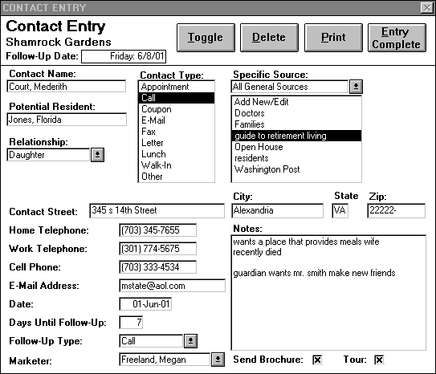

The marketing associate is ready to begin filling out the form. Choose the Contact Type:

Appointment- The marketing associate and the contact are meeting. Select this type if, for example, you conduct a previously scheduled tour.

Call- When the marketing associate or the contact initiates a telephone call.

Coupon- Select this type when the marketing associate receives a coupon in response to an advertisement or brochure.

E-Mail- Select this type when the marketing associate or the contact initiates contact with an e-mail.

Fax- Choose this type when the marketing associate or the contact initiates contact with a fax.

Letter- Choose this type when the marketing associate receives or writes a letter.

Lunch- Select this choice if you had lunch with the contact.

Walk-in- Choose this type when a contact comes to the property without a scheduled appointment.

Other- Use this option if you send or receive a fax. Also use this option when none of the others correctly describes the contact type.

Choose the Specific Source:
For each contact, a specific source must be selected. Since the marketer can choose only one source, the specific source is the source, which is most responsible for a potential resident contacting a facility. The general source list box filters the specific source list of choices into category. For example if you choose ‘Networking,’ all the specific sources with a general source of ‘Networking’ will appear in the list box. Most of the sources listed in this box pertain to a particular marketing event. For example, if an advertisement runs in the Washington Post, and the contact tells you that she learned about the property from the Post, then you would select (by pointing and clicking) "Washington Post" as the source. Other sources included in this list will be social service agencies (federal, state, and private), media, and resource books. While there may be many and various ‘Specific Sources,’ there are five pre-established categories of ‘General Sources’ from which to select, including:

Event- The source is an marketing event such as an Open House or High Tea.

Networking- The source is the result of a networking effort on the part of the facility staff such as a marketer visiting a hospital discharge planner.

Print Media- The source is an advertisement or article in the press.

Television- The source is an advertisement on television.

Word of Mouth- The source is not the result of a planned marketing effort, ad, or activity. Instead, the source is a result of community awareness. An example is a neighbor or resident family friend as a source.

When a marketing event yields a lead, the new source needs to be added to the list. By selecting the Specific Source entitled ‘Add New/Edit,’ you can access the “Add A Source” form through which both specific and general sources may be added or edited.

Add A Source

This form allows the marketing associate to add and edit sources. User-defined sources require careful thought since they impact the reports generated by the marketing module. The form is divided into four columns: ‘Specific Source,’ ‘General Source,’ ‘Active Contact Source,’ and ‘Active Referral Source.’ Each source consists of two parts, the ‘Specific Source’ and the ‘General Source.’ The columns ‘Active Contact Source’ and ‘Active Referral Source’ allow the user to activate a particular source for inclusion on the Contact Entry form and/or Referrals form.

To add a new specific source click on NEW SPECIFIC and type in the new source name. Make sure to select the general source to which the specific source corresponds. ‘Specific Source’ information is utilized to inform the marketer how productive each source is in terms of the leads and leases it generates over a given period of time. To add a new General Source click on GENERAL SOURCES and type in the new source name. To help you get started there are five pre-established categories of ‘General Sources’ which you can use, add to, or delete and create your own. The pre-established general sources are as follows:

Event- The source is an marketing event such as an Open House or High Tea.

Networking- The source is the result of a networking effort on the part of the facility staff such as a marketer visiting a hospital discharge planner.

Print Media- The source is an advertisement or article in the press.

Television- The source is an advertisement on television.

Word of Mouth- The source is not the result of a planned marketing effort, ad, or activity. Instead, the source is a result of community awareness. An example is a neighbor or resident family friend as a source.

To include a source on the Contact Entry form and/or Referrals form, highlight the desired source and check the ‘Active Contact Source’ and/or ‘Active Referral Source’ box(es). If a box is left unchecked in either column that particular source will not appear on the corresponding form.

If you would like to get an overview of the already existing sources, click the underlined arrow in the ‘Select the Desired Source to go to’ list box. You may move to a source by choosing the entry from the list box. To print out a current list of your sources, press the PRINT button. To delete a source from the list, select the sources and then click the DELETE button. Click the CLOSE button when finished to return to the "Contact Entry" form. The “Add A Source” form allows the use of the Sort Options Menu.
If you have not completed the requisite fields on this form, you will be alerted to your omission by a stop message. After reading the message, click OK and correct the mistake. If you are able to exit this form without completing the mandatory fields, your record will not be saved. The following fields must be completed in order to exit: Specific Source, General Source.

Exhibit 12: Add a Source Form

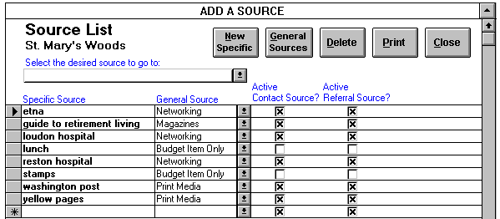

Contact Entry Form Continued (See Exhibit 11):

At the relationship box, click the underlined arrow to reveal the choices available. Remember to choose the term that defines the contact's relationship to the potential resident:

Brother- The contact is the potential resident's brother.

Daughter- The contact is the potential resident's daughter.

Daughter-in-law- The contact is the potential resident's daughter-in-law.

Guardian- The contact is the potential resident's legal guardian.

Grandchild- The contact is the potential resident's grand-child.

Professional- For example, choose this option if a DSS worker calls about admitting an elderly woman to your property; the DSS worker will be the contact as well as the source. Her relationship will be ‘professional.’

Self- The contact is the potential resident.

Sister- The contact is the potential resident's sister.

Son- The contact is the potential resident's son.

Son-in-law- The contact is the potential resident's son-in-law.

Spouse- The contact is the potential resident's husband or wife.

Other- Choose this option when none of the above correctly describes the relationship between the contact and the potential resident.

Complete the contact's address:

Street- Enter the contact's house number, street name, and unit number (if applicable).

City- Enter the city where the contact lives.

State- Enter the state where the contact lives.

Zip- Enter the contact's five digit zip code.

Complete the contact's phone numbers:

Home telephone- Enter the contact's home telephone number, with area code.

Work telephone- Enter the contact's work telephone number, with area code.

Cell phone- Enter the contact's cell telephone number, with area code.

E-mail address- Enter the contact's email address.

Date- Today's date will automatically appear in the date box in the format "dd-month-yy". This field can be updated to reflect the correct date.

Number of days until follow-up- The default number of days in this field is specified through the “Software Options” form. The contacts will be automatically tickled this number of days from the contact date. The number of days until follow-up should be determined on an individual basis by the marketing associate. Alter this field by moving the cursor to the field and entering the desired number of days until follow-up. If your follow-up date falls on a Saturday or Sunday, a message box will appear to alert you to this fact. You can either change the number of days until follow-up or let the weekend follow-up date stand.

Follow-up type- The type of follow-up chosen by the marketing associate will be displayed in the "Contact Tickler" form. By pointing and clicking, select the appropriate choice.

Appointment- Select this type when you have scheduled a meeting with the contact for the designated follow-up day.

Call- Select this option when you intend to call the contact on the designated follow-up date.

Fax- Select this option when you intend to fax the contact on the designated follow-up date.

E-mail- Select this option when you intend to e-mail the contact on the designated follow-up date.

Letter- Select this type when you intend to write to the contact on the designated follow-up day.

Lunch- Select this type when you intend to have lunch with the contact.

Tour- Select this type when you have scheduled a tour as the next follow-up action.

Other- Select this option when none of the others correctly describes your follow-up action.

None- If it is determined that a potential resident will not be admitted, select this type. If a lease is signed, and no further follow-up will be necessary, also select this type. Keep in mind that if ‘None’ is chosen, the contact will not appear in the “Contact Tickler” form.

Send Brochure- By clicking this box, the marketing associate is indicating that a brochure will be sent to this contact on the contact entry date. An "X" will appear when the box is clicked.

Tour- By clicking this box, the marketing associate is indicating that a tour was given to this contact on the contact entry date. An "X" will appear when the box is clicked.

Notes- Use this box to briefly include information that is no where else in the database. Be sure that your text is clear and succinct so that another associate will also be able to read it easily. For example, use this box if it is important to include that the potential resident is diabetic; or use this box to note if the contact has requested no phone calls. But do not use this box to include the potential resident's age or current home; that information is already on the "Client Contact Information" form.

Marketer - You now need to move to this box and select your name from the list. This field list contains the names of all the currently active employees allowed to enter contacts as entered in the Employee Information form. The marketer will appear on the Contact Tickler form.

When the "Contact Entry" form has been completed, you may exit by clicking the ENTRY COMPLETE button at the upper right-hand corner. The PRINT button is available if you wish to print out this contact entry form. If you have entered this contact by mistake, click the DELETE button to delete this contact entry record. If you have not completed some of the fields on this form, you will be alerted to your omission by a stop message. After reading the message, click OK and correct the mistake. If you are able to exit this form without completing the mandatory fields, your record will not be saved. The following fields must be completed in order to exit: Contact name
Potential resident name, Contact type, Specific Source, Date, Follow-up days, Follow-up type, Marketer.
Exhibit 13: Contact Entry Form

Recording A Follow Up Contact:

To get an overview of the contacts made on behalf of one particular resident, find the resident's record in the "Client Contact Information" form. Now click the VIEW CONTACTS button at the top of the form. You will see a list of contacts made. This form will stay on top of “Client Contact Information” and “Contact Entry” forms until you choose to close it. Close this form by clicking the CLOSE button.

Adding contact information about a contact who already exists in the database works very similarly to adding a first time contact. Once you have selected the correct resident record in the “Client Contact Information” form, click the NEW CONTACT button, which places you in a new “Contact Entry” form. If a different contact person for the same potential resident contacts you, you can click the DIFFERENT CONTACT button, instead of the NEW CONTACT button. Pressing this button will open the “Additional Contact For Resident” form where you can enter in this different contact’s first and last name. Clicking on the NEW CONTACT button places you in a new “Contact Entry” form, while pressing CANCEL closes the form without creating a new contact. Each different contact is recorded separately on the mailing list.

Once in “Contact Entry,” the contact's name and the resident's name should be complete and the following information will be updated: source, relationship, address, telephone numbers, and notes. You will, of course, need to supply the current information (contact type, # days until follow-up, follow-up type, marketer). Once again, you can exit the completed form by clicking the ENTRY COMPLETE button or print out the form by pressing the PRINT button. Click the DELETE button to delete a contact entry record entered by mistake.

If it is necessary to work on one potential resident's “Client Contact Information” form and “Contact Entry” form at the same time, you will want to use the TOGGLE button. This feature allows you to flip back and forth between the two records without requiring you to complete a record. The TOGGLE button will be helpful when talking to a contact over the phone.

Tickler Review

This feature was designed to let the marketing associate catch any leads or referrals that may have been tickled for a date when she was not at the office. At the "Contact Management Menu," click the TICKLER REVIEW button. Now, enter the date range from which you wish to review your tickler. Click the CONTACT TICKLER button to see all the leads that should have been tickled for your date range. Or click the REFERRAL TICKLER to view the referrals that should have been tickled for your date range. The leads and referrals will be ordered from the most recent to the least recent, starting at the top of the form. Only those contact and referral tickles, which have not yet been followed up on by marketing, will show up on the tickler review forms. The TICKLER REVIEW can also be used to preview leads and referrals that will be tickled in the future. Once you have accessed the desired tickler form, you can use the address features, print features, and CLOSE buttons. On the “Contact Tickler” form, marking an ‘X’ in the ‘Open to Client Contact Information’ box opens the “Client Contact Information” to the potential resident record of the selected contact tickler record. Close “Client Contact Information” and you will return to the “Contact Tickler.” While this box is “X”ed, selecting the desired tickler record will open to the corresponding Client Contact Information record. Conversely, on the “Referral Tickler” form, marking an ‘X’ in the ‘Open to Referrals’ box opens the Referrals form to the potential resident record of the selected contact tickler record. Close Referrals and you will return to the “Referral Tickler.” While this box is “X”ed, selecting the desired tickler record will open to the corresponding Referrals record.

Both the Referral and Contact Tickler forms allow the use of the Advanced Options Menu. Click the CANCEL button to terminate the review and return to the “Contact Management Menu.”

Exhibit 14: Tickler Review

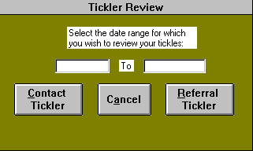

Contact Review

In order to view a lead's most recent contact, click the CONTACT REVIEW button from the “Contact Management Menu” to open the “Contact Review” form. For example if today's tickler reminded you that you have an appointment at 10:00 a.m. with a potential resident's daughter, you may be interested in looking at the information from your most recent contact with her. Therefore, you would select the potential resident or contact name from the appropriate list and click the button for the desired search to open the “Contact Entry” form to the appropriate contact. Clicking the ENTRY COMPLETE button returns you to the “Contact Review” form. Use the CANCEL button to terminate your search and return to the “Contact Management Menu.” Please only change information through this form if it is absolutely necessary. Do not ever use this form to record a new contact.

Exhibit 15: Contact Review
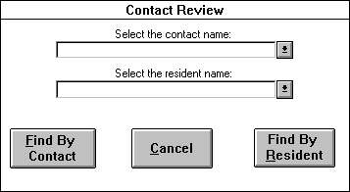

Referrals

Exhibit 16: Referrals Form

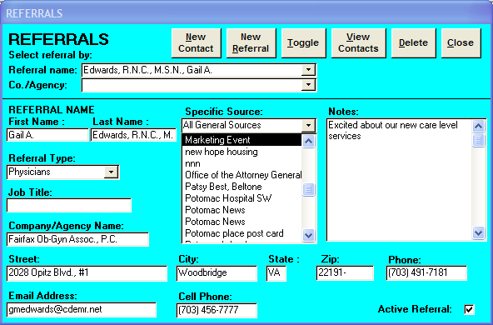
Click the REFERRALS button on the "Contact Management Menu" to access the "Referrals" form. These forms are designed to collect information about people who provide referrals to your property, but who may not contact you about placing a specific resident. These people are probably in contact with you periodically about your property's services so that they can offer the information to their own clients. For example, a residential agent at Long & Foster Realtors may choose to keep abreast of local elderly living options so that she may provide that information to home buyers who may be looking for housing for their parents. In this case, the agent would be the referral; you would want to record your contacts with her; and you may want to keep her informed through your marketing events.

Remember that a referral is someone who will generate leads for you; the referral will direct potential contacts to your property. If a referral is working on placing a specific resident in your property, that referral could become a contact for the potential resident; and the referral should then be treated like a contact within the program as long as she is acting in that capacity. Usually though, the referral refers your facility to a potential resident or resident family member who becomes the potential resident’s contact person. In this case, the referral is not the contact, but the source.
Entering a referral:
You can search for a referral making a contact either by referral name or company agency name, whichever is easier. The referral name list sorts the referrals in alphabetical order by referral name, while the company/agency name list sorts alphabetically by company/agency name. If the referral cannot be found in these lists, then the referral is a first time contact and you need to click the NEW REFERRAL button and complete the following information:

Referral first name- Enter the person's first name.

Referral last name - Enter the person’s last name.

Referral type- Select the appropriate referral type from the list. If you do not see the desired referral type, you can create it by selecting "Add New/Edit" to open the “Referral Type Choices” form. This form lists all your current referral types. You can then either add a new referral type at the bottom of the list or edit an incorrect current referral type. Click the PRINT button to print this list and the CLOSE button to return to the “Referrals” form. When you return to the “Referrals” form, pull up the referral type list again, and the referral type that you just added will appear on the list. Click the mouse button on that referral type, and it will be selected.

Job title- Enter the name of the position that the referral holds if available.

Company/Agency name- Enter in the name of the company, which employs the referral.

Street- Enter the street name, building number, and unit number of the referral's business address.

City- Enter the city where the referral works.

State- Enter the state where the referral works.

Zip- Enter the five digit zip code appropriate for the referral's business address.

Referral telephone- Enter the phone number, including the area code and any applicable extension code.

Cell phone- Enter the referral's cell telephone number, with area code.

E-mail address- Enter the referral's email address.

Active Referral - Mark this box with an “X”, if you wish this referral to remain active and appear on your referral mailing list. Unmark this field if you desire the referral to drop off the mailing list.

Notes- Use this box to briefly include information that is no where else in the database. Be sure that your text is clear and succinct so that another associate will be able to read it easily.

Specific source- Since the marketing associate can choose only one source, the specific source is the source, which is most responsible for a referral learning of your facility. The general source list box filters the specific source list of choices. For example if you choose ‘Networking,’ all the specific sources with a general source of ‘Networking’ will appear in the list box. Most of the sources listed in this box pertain to a particular marketing event. For example, if an advertisement runs in the Washington Post, and the contact tells you that she learned about the property from the Post, then you would select (by pointing and clicking) "Washington Post" as the source. Other sources included in this list will be social service agencies (federal, state, and private), media, and resource books. When a marketing event yields a lead, the new source needs to be added to the list. Select "Add New/Edit" and you can access “Add A Source” form and add a new source to your list.

Add A Source

This form allows the marketing associate to add and edit sources; user-defined sources require careful thought since they impact the reports generated by the marketing module. The form is divided into four columns: ‘Specific Source,’ ‘General Source,’ ‘Active Contact Source,’ and ‘Active Referral Source.’ Each source consists of two parts, the ‘Specific Source’ and the ‘General Source.’ The columns ‘Active Contact Source’ and ‘Active Referral Source’ allow the user to activate a particular source for inclusion on the Contact Entry form and/or Referrals form.

To add a new specific source click on NEW SPECIFIC and type in the new source name. Make sure to select the general source to which the specific source corresponds. ‘Specific Source’ is utilized to inform the marketer how productive each source is in terms of the leads and leases it generates over a given period of time. To add a new general source click on GENERAL SOURCES and type in the new source name. To include a source on the Contact Entry form and/or Referrals form, highlight the desired source and check the ‘Active Contact Source’ and/or ‘Active Referral Source’ box(es). If a box is left unchecked in either column that particular source will not appear on the corresponding form.

If you would like to get an overview of the already existing sources, click the underlined arrow in the ‘Select the Desired Source to go to’ list box. You may move to a source by choosing the entry from the list box. To print out a current list of your sources, press the PRINT button. To delete a source from the list, select the sources and then click the DELETE button. Click the CLOSE button when finished to return to the “Referrals” Form. The “Add A Source” form allows the use of the Sort Options Menu.

If you have not completed the requisite fields on this form, you will be alerted to your omission by a stop message. After reading the message, click OK and correct the mistake. If you are able to exit this form without completing the mandatory fields, your record will not be saved. The following fields must be completed in order to exit: Specific Source, General Source. Click the CLOSE button to return to the Referrals form.

Every time contact is made with a referral, including the first, you need to click the NEW CONTACT button at the top of the "Referrals" form. You will need to supply the current information on the “Referral Contact Entry” form (See entering a referral contact). You can toggle back to the “Referrals” form, by clicking anywhere on the form. Pressing the TOGGLE button, will then return you to the “Referral Contact Entry” form.
A referral, unless it has a direct mail referral type, should have multiple contacts. To get an overview of the contacts made on behalf of a referral, click the VIEW CONTACTS button at the top of the “Referrals” form. You will see a list of referral contacts made. Of course this form will be empty for a first time referral. Pressing the PRINT button will print out this form. Close this form by clicking the CLOSE button.

If you have entered in a referral in error, use the DELETE button to discard your record. Please use the DELETE button judiciously, deleting a referral record also deletes all the referral contacts associated with that record. If the error was just a mistakenly entered “Referral Contact Entry” record, click the DELETE CONTACT button to remove the record.

When you are finished with the "Referrals" and “Referral Contact Entry” forms, click the CLOSE button to return to the “Contact Management Menu.” If you have not completed some of the key fields in this form, you will be alerted by a stop message. Click OK and correct your mistakes before attempting to exit the form again. If you are able to exit the form without completing the mandatory fields, your record will not be saved. The following fields must be completed before exiting: Referral first name, Referral last name, Referral type, Specific source.

Entering a referral contact:

Exhibit 17: Referral Contact Entry

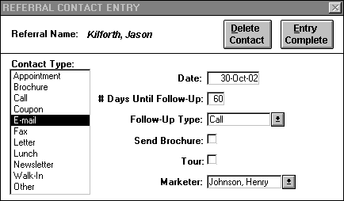

For every contact made with a referral, a “Referral Contact Entry” form must be filled out, including the first contact. When you are finished entering data in the “Referrals” form, you need to click the NEW CONTACT button located at the top of the "Referrals" form. This will open the “Referral Contact Entry” form. You can toggle back to the “Referrals” form, by clicking anywhere on the “Referrals” form. Pressing the TOGGLE button, will then return you to the “Referral Contact Entry” form. For each referral contact the following information will be entered:

Contact type- Point to and select the appropriate term:

Appointment- The marketing associate and the referral are meeting. Select this type if you have an appointment together or you conduct a previously scheduled tour.

Call- When the marketing associate or the referral initiates a telephone call.

Coupon- Select this type when the marketing associate receives a response to an advertisement or brochure.

E-mail- Select this type when the marketing associate or the referral initiates an e-mail.

Fax- Select this type when the marketing associate or the referral initiates a fax.

Letter- Choose this type when the marketing associate receives or writes a letter.

Lunch- Choose this type if you had lunch with the referral.

Newsletter- Choose this option if you send the referral a newsletter.

Walk-in- Choose this type when a referral comes to the property without a scheduled appointment.

Other- Choose this type if you send or receive a fax. Also choose this type when none of the others accurately describes your contact type.

Date- Today's date will automatically appear in the "dd-month-yy" format. This field can be updated to reflect the correct date.

# Days until follow-up- The default number of days in this field is specified through the “Software Options” form. The contacts will be automatically tickled this number of days from the contact date.
The number of days until follow-up should be determined on an individual basis by the marketing associate.

Follow-up type- The type of follow-up chosen by the marketing associate will be displayed in the "Referral Tickler" form. By pointing and clicking, select the appropriate choice.

Call- Select this when you intend to call the referral on the designated follow-up date.

E-mail- Select this when you intend to e-mail the referral on the designated follow-up date.

Fax- Select this when you intend to fax the referral on the designated follow-up date.

Letter- Select this type when you intend to write to the referral on the designated follow-up day.

Lunch- Select this type when you plan to have lunch with the referral.

Appointment- Select this type when you have scheduled a meeting with the contact for the designated follow-up day.

Tour- Select this type when you have scheduled a tour as the next follow-up action.

Other- Select this type when none of the others appropriately describes the designated follow-up type.

None- If it is determined that no follow-up is necessary for this referral, choose none.

Send Brochure- By clicking this box, the marketing associate is indicating that a brochure will be sent to this referral on the contact entry date. An "X" will appear in the box.

Tour- By clicking this box, the marketing associate is indicating that a tour was given on the contact entry date.

Marketer- You now need to move to this box and select your name from the list. This field list contains the names of all the currently active employees allowed to enter contacts as entered in the “Employee Information” form. The marketer will appear on the “Referral Tickler” form.

If you have entered in a referral contact in error, use the DELETE CONTACT button to discard your record. If you wish to delete a referral record and all its contacts click the DELETE button on the “Referrals” form. When you are finished with the "Referral Contact Entry" form, click the ENTRY COMPLETE button to return to the “Referrals” form. If you have not completed some of the key fields in this form, you will be alerted by a stop message. Click OK and correct your mistakes before attempting to exit the form again. If you are able to exit the form without completing the mandatory fields, your record will not be saved. The following fields must be completed before exiting: Contact type, Date, Follow-up days, Follow-up type, Marketer.

Lost Tickler Report

Exhibit 18: Lost Tickle Options

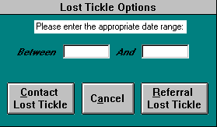

Click this button to view and print a list of resident or referral contacts that have been inadvertently “dropped” by the marketing associate(s). You must first enter in an appropriate date range for the contacts that have been inadvertently "dropped" by the marketing associate(s). The user is given two types of Lost Tickles to choose from:

Contact Lost Tickle - Clicking this button opens the “Lost Contact Tickler” form, which displays potential resident contacts that have not been followed up. This form will contain the following information: marketer name, contact name, potential resident name, and the missed follow-up date. Press the PRINT button to print out the form, and the CLOSE button to close it. The “Lost Contact Tickler” form allows the use of the Sort Options Menu.

Exhibit 19: Lost Contact Tickler

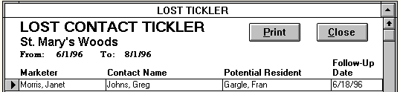

Referral Lost Tickle - Clicking this button opens the “Lost Referral Tickler” form, which displays referral contacts that have not been followed up. This form will contain the following information: marketer name, referral name, company/agency name, and the missed follow-up date. Press the PRINT button to print out the form, and the CLOSE button to close it. The “Lost Referral Tickler” form allows the use of the Sort Options Menu.

Exhibit 20: Referral Lost Tickler

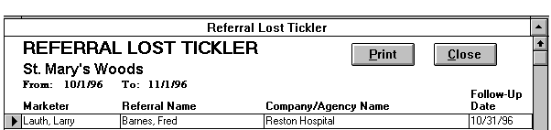

Room Availability

The marketing associate uses this form to check on the property's available and soon to be available rooms. Based on information already in the database (i.e., leases signed, move-outs, room plan), the program will be able to determine the room availability and type on a daily basis. The list of available rooms will be ordered by room type by default. If the ‘resident name,’ ‘move-out date,’ and ‘lease end date’ fields are blank, the room is currently available. If these fields are not blank, the resident name indicates the resident that is moving out; the move-out date reflects the date the resident will be physically out of the building; and the lease end date is the last day of financial responsibility. “Room Availability” also allows the marketing associate to view specific notes displayed in the ‘Room Description’ and ‘Marketer Notes’ fields. ‘Room Description,’ which is entered through the “Room Plan” form, may provide information helpful in marketing a particular room, such as ‘full bath, close to elevator.’ ‘Marketer Notes,’ which are entered on the “Room Availability” form, allow the marketing associate to document any other important information regarding a particular unit not categorized as description, such as ‘Don’t lease apartment; saving for Mr. Smith.’ Once a unit is rented, the attached ‘Marketer Notes’ are deleted automatically.

Use the PRINT button if you would like to print a copy of this form. Click the CLOSE button when you are finished. The “Room Availability” form allows the use of the Sort Options Menu.

Exhibit 21: Room Availability Form

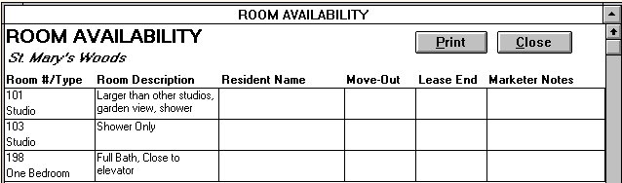

Waiting List

The “Waiting List” allows you to organize and track important information regarding the status and preferences of potential and current residents who are waiting for units to become available in your facility. Print the list to determine which resident is first in line for a specific item. When the standing of a potential resident is "Waiting List" on the "Client Contact Information" form, her name and item waited for should appear on the “Waiting List Form.” If her status changes to ‘In Process,’ ‘Lease Signed,’ ‘Not Coming,’ or ‘On Hold,’ her name will be removed from the waiting list. The "Waiting List" form will sort by default in order of the resident/potential resident designation, the item waited for, and the specific item.

Open opening, the form will detail all current and potential residents currently selected for the waiting list; a column to the left of the resident/contact name distinguishes current from potential residents with the designation “R” for current resident and “P” for potential resident. To add a current resident to the waiting list, click on the In-House Add button; the “In-House Add” form will appear with fields similar to that of the “Waiting List” entered through “Client Contact Information,” allowing the user to record all information pertinent to the “Waiting List” form.

The “Waiting List ” and “In-House Add” forms display the following fields, which may be modified as waiting list information changes:

Fields

Waiting For- The general category into which a current or potential resident’s unit preference falls. The marketing associate selects from ‘Special Income Program,’ ‘Specific Floor,’ ‘Room Type,’ ‘Combination’ of preferences, i.e. room and floor, or ‘Other’ category of preference not listed.

Specific Item- The specific type of unit preference, for example a potential resident may elect to wait for an apartment on the ‘1st Floor,’ a specific item found under the category ‘Specific Floor.’

Entry Date- The first day a resident or potential resident is added to the “Waiting List.” This field is used to determine the order of current and potential residents waiting for an opening. A new entry date is required if a current or potential resident declines a unit-opening, thereby forfeiting his current place on the waiting list.

Fee collected- The dollar amount received from a current or potential resident/contact to secure a place on the wait list.

Marketer- The full name of the marketing associate who entered specific information on the Waiting List form. This field list contains the names of all the currently active employees allowed to enter contacts as entered in the “Employee Information” form.

Notes- any further information necessary to clarify a current or potential residents accommodation status, particular situation, or specific preferences.

Through the use of filters, the “Waiting List” allows the Marketing Associate to single-out data or refine the form based on certain “Waiting List” criteria. To initiate a filter, click on the left of the desired filter section and choose the desired item from the list of choices. Then you can either choose another filter selection to refine your list even more or process the records with the current selection. Pressing the FILTER button reduces the records to the defined filter option selections. Click the UNFILTER button to show all the records again. The following filters are located in the upper left-hand side of the form:

Filters

Waiting For- Filters by the general category into which a current or potential resident’s accommodation preference falls, i.e. ‘Special Income Program,’ ‘Specific Floor,’ ‘Room Type.’

Specific Item- Filters by the specific accommodation preference, i.e. ‘1st Floor.’

Fee collected- Filters by the dollar amount received from a current or potential resident/contact in securing a place on the waiting list.

Marketer- Filters by the full name of the marketing associate who entered specific information on the “Waiting List” form.

Date Range- Filters records for a user-defined period of time based on entry date.

Use the PRINT button to print out a report of the form and the CLOSE button to close the form. “Waiting List” allows the use of the Advanced Options Menu.

Exhibit 22: Waiting List Form

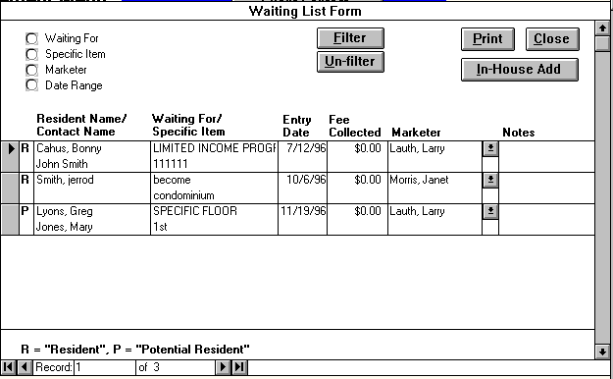

Label Options

Click this button to select which type of mailing labels you wish to print: contact labels, referral labels, or resident labels.

Exhibit 23: Label Options

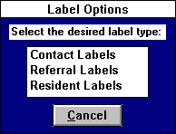

The following is description of your three mailing label options:

Contact Labels
Click this button to open the “Contact Label Options” form to print mailing labels for contact leads in the marketing database. The contacts who are excluded are the ones whose status are ‘Lease Signed’ or ‘Not Coming.’ You can choose to print out all the active contacts by selecting ‘All,’ or filter the active contacts by standing, level of care, initial contact date, or a combination of the three. If you wish to know the number of labels you will be printing out, click the LABEL COUNT button. Once you have selected which contact labels you wish to print, click on PRINT LABELS button. If you do not wish to print any contact labels, click CANCEL and return to the “Contact Management Menu.”

Exhibit 24: Contact Label Options

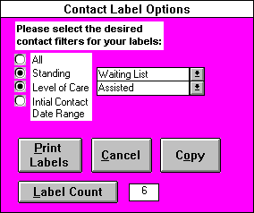

The COPY button will copy the following information to the Windows clipboard which can be retrieved using the Paste command in another Windows application: Resident First Name, Resident Last Name, Contact First Name, Contact Last Name, Contact Street, City, State, Zip, Relationship, Initial Contact Date, Standing, and Level of Care Desired. If you select the ‘By Initial Contact Date’ option, then clicking the COPY button will only copy the contacts whose initial contact date are within the specified date range. This will be especially useful in Microsoft Word for Windows where you can perform a mail merge to send out marketing letters.

Referral Labels
Click this selection to open the “Referral Label Options” form to print labels for your referrals. You will be prompted to select which type of referrals you want labels printed for. If you want to prepare a mailing for all your referrals from doctors, you would choose ‘Doctors’ from the list. Only active referrals who were categorized as ‘Doctors’ would get labels printed. Selecting the ‘All (except direct mail)’ choice will generate a label for all of your active referrals, except those with a referral type of ‘Direct Mail.’ After making your selection, click the PRINT LABELS button to print. The label count property identifies the number of labels a selected referral type will generate.

The COPY button will copy the following information for the specified referral type to the Windows clipboard which can be retrieved using the Paste command in another Windows application: Referral First Name, Referral Last Name, Job Title, Company/Agency Name, Referral Street, City, State, Zip, Referral Type. The COPY button will only copy the records of the referral type you have selected. This will be especially useful in Microsoft Word for Windows where you can perform a mail merge to send out marketing letters.

Exhibit 25: Referral Labels

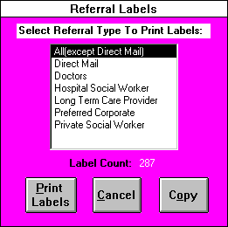

Resident Labels

Select this option to open “Resident Label Options” to print resident labels. Use the CANCEL button to return to the "Contact Management Menu.” You will be prompted to choose which type of labels to print. The label count box tells the user how many labels each selection will print. Click the PRINT LABELS button after you have made your selection from the following list:

Exhibit 26: Resident Label Options

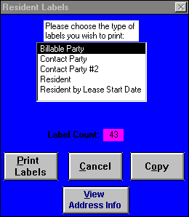

Billable Party- All persons who are the Billable Parties for Residents; this includes Billable Parties for Residents who have not physically moved out and for Residents who have signed leases without yet moving in.

Contact Party- All persons who are the Contact Parties for Residents; this includes Contact Parties for Residents who have not yet physically moved out and for Residents who have signed leases without yet moving in.

Contact Party #2- All persons who are the second Contact Parties for Residents; this includes Contact Parties #2 for Residents who have not yet physically moved out and for Residents who have signed leases without yet moving in.

Resident- All tenants who have signed a lease and have not physically moved out. Also included are Residents who have signed leases without yet moving in.

Resident by Lease Start Date- If you select this type, you need to specify a date range before clicking PRINT LABELS.

The VIEW ADDRESS INFO button opens the form “Billable/Contact Party Info” which lists the contact and billable party addresses for all the residents who have signed leases who have not yet physically moved-out.

The COPY button will copy the following information for the specified type to the Windows clipboard, which can be retrieved using the Paste command in another Windows application. This will be especially useful in Microsoft Word for Windows where you can perform a mail merge to send out marketing letters.

Billable Party - Resident First Name, Resident Last Name, Billable Party, Billable Party Address, City, State, and Zip.

Contact Party - Resident First Name, Resident Last Name, Contact Party Name, Street, City, State, Zip, Relationship.

Contact Party #2 - Resident First Name, Resident Last Name, Contact Party #2 Name, Street, City, State, Zip, Relationship.

Resident - Resident First Name, Resident Last Name, Room #, and Lease Start Date.

Resident By Lease Start Date - Resident First Name, Resident Last Name, Room #, and Lease Start Date for the given date range.

RETURN TO MAIN MENU
If you want to exit Market Leap, click the RETURN TO MAIN MENU button on the “Contact Management Menu.” You will then see the "Main Menu." If you still want to exit Market Leap, click the button with that heading. If you want to return to a particular menu, click on the button with the menu name, for example to return to “Resident Tracking,” you would click on the RESIDENT TRACKING MENU button. Click RETURN TO MAIN MENU button to exit from the current menu and return to the "Main Menu."

Part IV

Market Analysis Menu
To access this menu, click the MARKET ANALYSIS MENU button on the "Main Menu." Through the “Market Analysis Menu," the user will be able to review and print numerous reports helpful to the evaluation of marketing activity and its effectiveness.

Exhibit 27: Market Analysis Menu

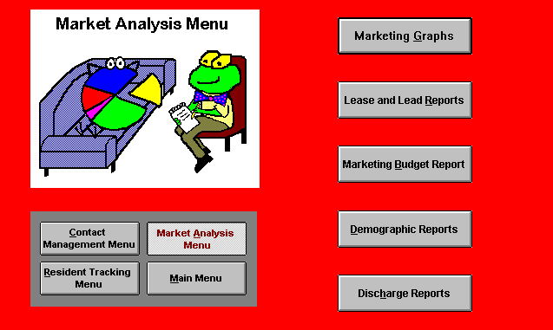

Marketing Graphs
Click this button to view and/or print a selection of marketing graphs. You may click CANCEL to avoid viewing any of the graphs and to return to the “Market Analysis Menu.” Select among the following choices shown in Exhibit 28:

Exhibit 28: Marketing Graph Options

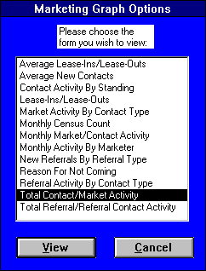

Average Lease-Ins/Lease-Outs
This form shows the average number by month of lease-ins, lease-outs, and the net lease-ins/lease-outs for a user defined date range. The “Monthly Averages” graph located in the lower right corner provides the average lease-ins, lease-outs, and net over the specified date range. If you wish to change the date range, type in the appropriate date boxes the time period you wish to see, and click the UPDATE GRAPHS button. This action will cause the graphs to change to reflect the new date range. If you wish to print the graphs, click the PRINT button. Clicking the close button will return you to the “Marketing Graphs Options” form. (Note: The lease-ins and lease-outs are based on the lease start date and lease end date respectively, and do not include respite leases.)

Exhibit 29: Average Lease-Ins/Lease-Outs Form

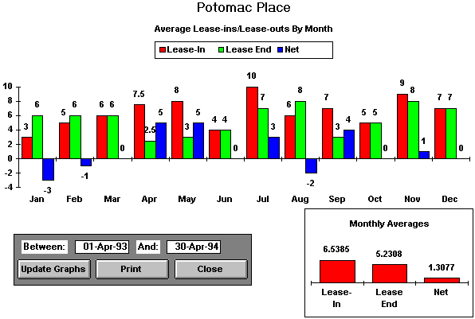

Average New Contacts
This form shows the average number by month of new contacts for the user defined date range. If you wish to change the date range, type in the appropriate date boxes the time period you wish to see, and click the UPDATE GRAPHS button. This action will cause the graphs to change to reflect the new date range. If you wish to print the graphs, click the PRINT button. Clicking the CLOSE button will return you to the “Marketing Graphs Options” form. (Note: The new contacts are based on the initial contact dates.)

Exhibit 30: Average New Contacts

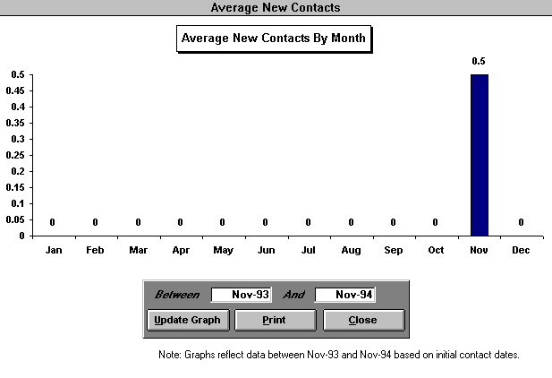

Contact Activity By Standing
This form shows a rolling, 13 month graph of the number of new contacts broken out by standing. The user chooses the standing (On Hold, In Process, Lease Signed, Waiting List, Not Coming) from the standing list box. The graph in the lower right corner shows the average monthly number of new contacts by standing for the last 13 months. All new contacts are based on their initial contact date. The PRINT button prints out the graph, while the CLOSE button closes the form and returns the user to the “Market Analysis Menu.”

Exhibit 31: Contact Activity By Standing Form

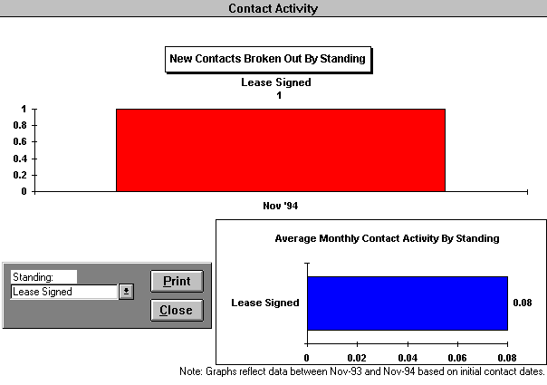

Lease-Ins/Lease-Outs
This form shows a rolling, 13 month graph of the number of lease-ins, lease-outs, and net lease-ins and lease-outs. The PRINT button prints out the graph, while the CLOSE button closes the form and returns the user to the “Marketing Graphs Options” form. (Note: The lease-ins and lease-outs are based on the lease start date and lease end date respectively, and do not include respite leases.)

Exhibit 32: Lease-Ins/Lease-Outs Form

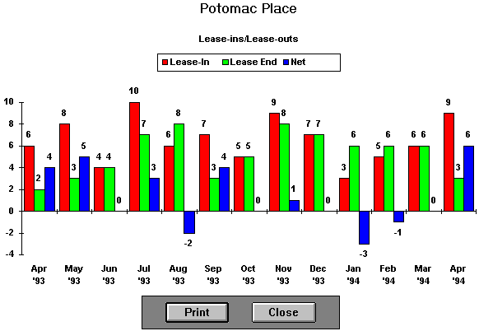

Market Activity By Contact Type
This form shows a rolling, 13 month graph of the number of contacts made and received by the marketing staff broken out by contact type. The user chooses the contact type (Appointment, Call, Coupon, Letter, Lunch, Other, Walk-In) from the contact type list box. The graph in the lower right corner shows the average monthly number of contacts made and received by contact type for the last 13 months. All contacts are based on their respective contact dates. The PRINT button prints out the graph, while the CLOSE button closes the form and returns the user to the “Marketing Graphs Options” form.

Exhibit 33: Market Activity By Contact Type Form

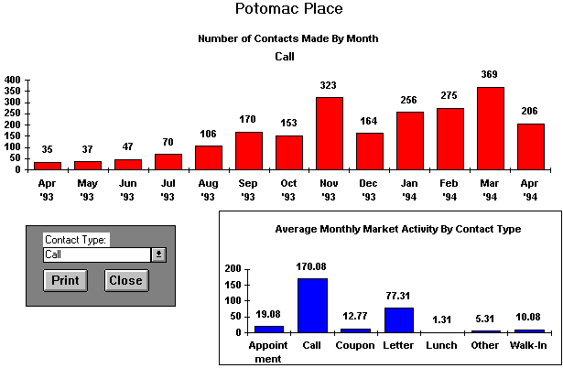

Monthly Census Count
This form shows a rolling, 13 month graph of a facility’s unit census as of the first day of each month.. The PRINT button prints out the graph, while the CLOSE button closes the form and returns the user to the "Marketing Graphs Options" form. (Note: The unit census is based on the lease start date, lease end date, and unit count fields respectively.)

Exhibit 34: Monthly Census Count

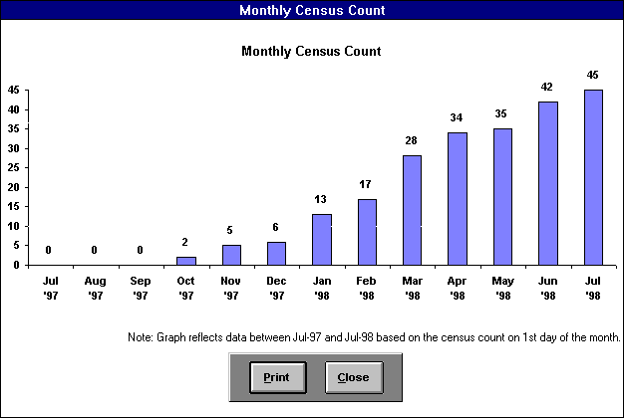

Monthly Market/Contact Activity
This form contains two graphs, “Market Activity By Contact Type” and “New Contact Activity By Standing” for the user-specified month. The first graph shows the total number of contacts of each contact type(Appointment, Call, Coupon, Letter, Lunch, Other, Walk-In) that have been made in the specified month. If a contact type does not appear on the graph, then no contacts were made in that month of that particular contact type. The second graph displays the number of new contacts of each standing(On Hold, In Process, Lease Signed, Waiting List, Not Coming) that has been made in the specified month. This graph is based on the initial contact date of each new contact. To change the specified month, simply type in the date box a date in the month you wish to view and press enter. The PRINT button prints out the graphs, while the CLOSE button closes the form and returns the user to the “Marketing Graphs Options” form.

Exhibit 35: Monthly Market/Contact Activity

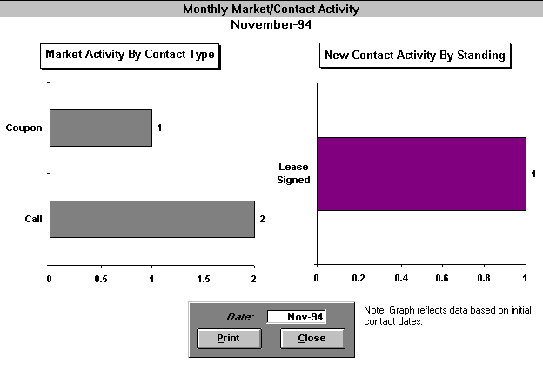
Monthly Activity By Marketer
This form contains two graphs, “Monthly Market Activity By Marketer” and “Monthly New Contacts By Marketer” for the user specified month. The first graph shows the total number of each contact type(Appointment, Call, Coupon, Letter, Lunch, Other, Walk-In) that has been made by each marketer in the specified month. The second graph displays the number of new contacts of each marketer made in the specified month. This graph is based on the initial contact date of each new contact. To change the specified month, simply type in the date box a date in the month you wish to view and press enter. The PRINT button prints out the graphs, while the CLOSE button closes the form and returns the user to the "Marketing Graphs Options" form.

Exhibit 36: Monthly Activity By Marketer

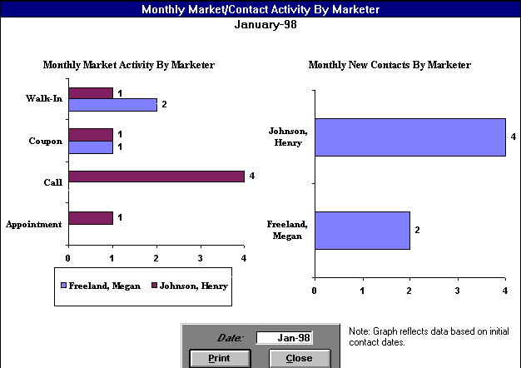

New Referrals By Referral Type
This form shows a rolling, 13 month graph of the number new referrals broken out by referral type. The user chooses the appropriate referral type from the referral type list box. The graph in the lower right corner shows the top five referral types in terms of average monthly number of new referrals for the last 13 months. All new referrals are based on their initial referral contact dates. The PRINT button prints out the graphs, while the CLOSE button closes the form, and returns the user to the “Market Analysis Menu.”

Exhibit 37: New Referrals By Referral Type

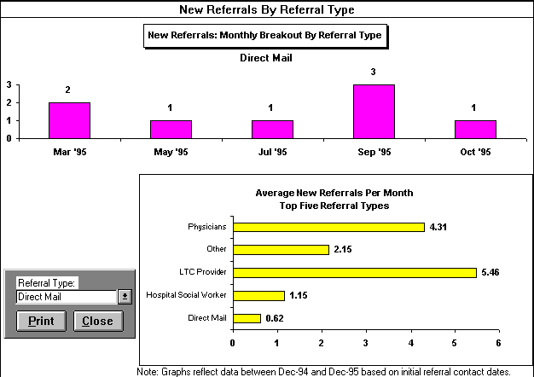

Reason For Not Coming
This form graphically displays the reasons for not coming of uninterested prospects for the user defined date range. If you wish to change the date range, type in the appropriate date boxes the time period you wish to see, and click the UPDATE GRAPHS button. This action will cause the graph to change to reflect the new date range. If you wish to print the graphs, click the PRINT button. Clicking the CLOSE button will return you to the "Marketing Graphs Options" form. (Note: The graph is based on the reasons selected in the "Reason For Not Coming" form.)

Exhibit 38: Reason For Not Coming

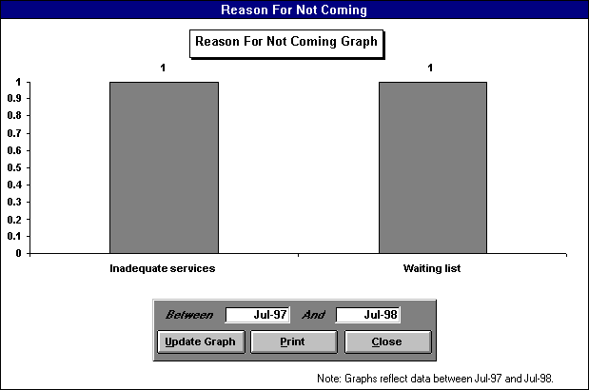

Referral Activity by Contact Type
This Form shows a rolling, 13 month graph of the number of referral contacts broken out by contact type. The user chooses the contact type (Appointment; Brochure; Call; Coupon; Letter; Lunch; Newsletter; Walk-In; Other) from the contact list box. The graph in the lower right corner shows the average monthly number of referral contacts made and received by contact type for the last 13 months. All contacts are based on their respective contact dates. The PRINT button prints out the graph, while the CLOSE button closes the form and returns the user to the “Market Analysis Menu.”

Exhibit 39: Referral Activity By Contact Type

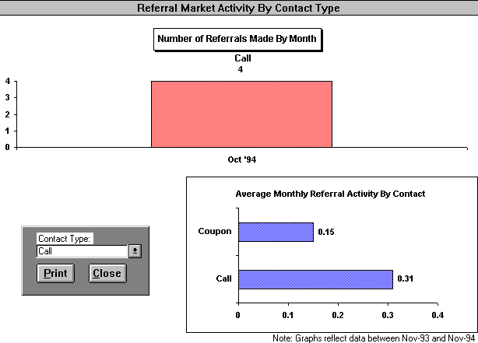

Total Contact/Market Activity
This form contains two graphs, “New Contacts By Month” and “Total Amount of Market Activity By Month.” This first one is a rolling 13 month graph, which shows the total number of new contacts by month. These new contacts are based on their initial contact dates. To go to the second graph(See Exhibit 41), click the MARKET TOTALS button. This second graph displays the total number of contacts received and made in each of the last 13 months. To return to the first graph(See Exhibit 40), click the CONTACT TOTALS button. The PRINT buttons prints out the graphs, while the CLOSE button closes the form and returns the user to the “Marketing Graphs Options” form.

Exhibit 40: Total Contact/Market Activity, New Contacts By Month Graph

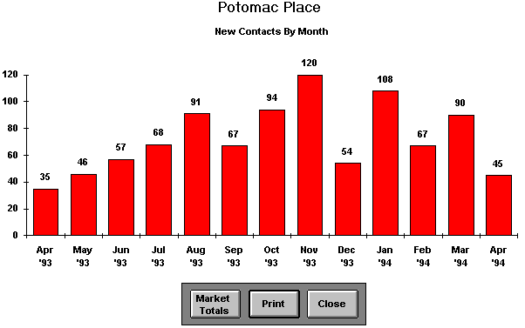

Exhibit 41: Total Contact/Market Activity, Total Amount of Market Activity By Month
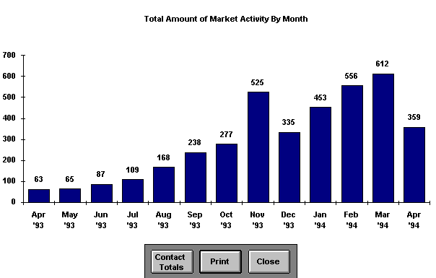

Total Referral/Referral Contact Activity
This form contains two graphs, "Total Referral Activity by Month" and "New Referrals Developed by Month.” The first graph (Exhibit 42) displays the total number of referral contacts received and made in each of the last 13 months. To access the second graph, click the NEW REFERRALS button. This second graph(Exhibit 43) is a rolling 13 month graph, which shows the total number of new referrals by month. These new referrals are based on their initial contact dates. To return to the first graph, click the REFERRAL ACTIVITY button. The PRINT buttons prints out the graphs, while the CLOSE button closes the form and returns the user to the “Marketing Graph Options” form.

Exhibit 42: Total Referral Activity

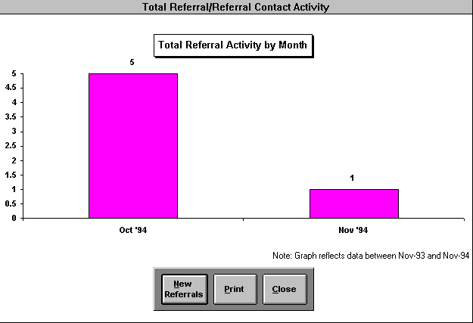

Lease and Lead Reports

Use this button to view and print reports on the success of your marketing events. You can terminate this function by clicking the CANCEL button; you will be returned to the "Market Analysis Menu." By clicking the VIEW FORM button you can view the form, which you have selected from the list below:

Exhibit 43: Lead/Lease Reports

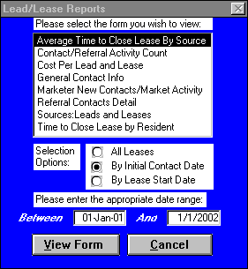
Average Time To Close Lease By Source
Select this report to review by source the average number of days between a resident’s initial contact date and lease start date. You can review either for all leases or an user defined date range. You can select your date range either to span initial contact or lease start dates. This form allows the use of the Sort Options Menu.

Exhibit 43: Average Time To Close Lease By Source

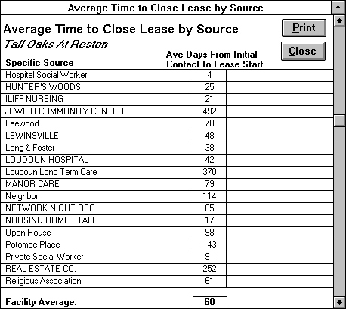

Contact/Referral Activity Count
This form provides the user with contact and referral activity counts over a specified date range. Specifically the form yields counts for the following categories: new contacts by standing, contact activity by contact type, new referrals by referral type, and referral activity by contact type. Previously, this information has been available graphically on a monthly basis. The advantage of this form is that the information is grouped together on one form and can be based on any date range the user desires from a day, a week, a year, etc.

Exhibit 44: Contact/Referral Activity Count

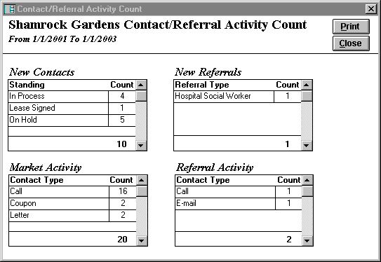

Cost Per Lead and Lease
Choose this report for an account of your marketing events and how many leads and leases they generated. The report will also detail the cost of each lead and lease based on the event cost. When you select this report, you are asked to enter the year for which you wish to see the breakout of leads and leases. If you enter the current year, the report will only factor source costs through the current month, not the entire year. If a no-cost marketing event (e.g., "hospital social worker") generates leads or leases, no cost will be assigned to the lead or lease. Leads and leases are based on the potential resident’s initial contact date, not on the last contact date or lease start date.

Exhibit 45: Cost Per Lead & Lease Form

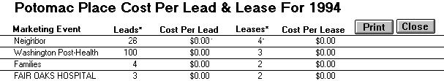

General Contact Info
This is a read only form which displays the following information about a facility’s contacts for a user-specified initial contact date range: resident name, contact name, standing, specific source, contact city, contact state, and the initial contact date for a specified date range. Each potential resident/resident from the “Client Contact Information” form is included in this list, given the appropriate date range. This form allows the use of the Advanced Options Menu.

Exhibit 46: General Contact Info
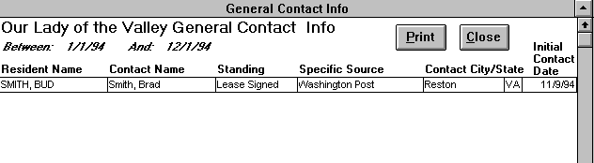

Sources: Leads and Leases By Date Range
Choose this report for a summary of sources and the number of leads and leases they generate. You will be prompted to enter a specific date range. Leads and leases also are based on the potential resident’s initial contact date, not on the last contact date or lease start date.

Exhibit 47: Sources: Leads and Leases

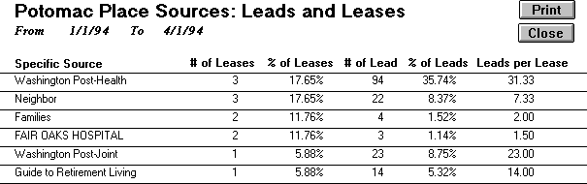

Marketer New Contacts/Market Activity
Select this form to view a rolling, 13 month breakout of the number of new contacts and market activity by each marketer. The marketer involved in the potential resident’s initial contact gets credit for the new contact. On the other hand, market activity is the total number of calls, letters, appointments, etc. the marketers have performed each month.

Exhibit 48: Marketer New Contacts/Market Activity

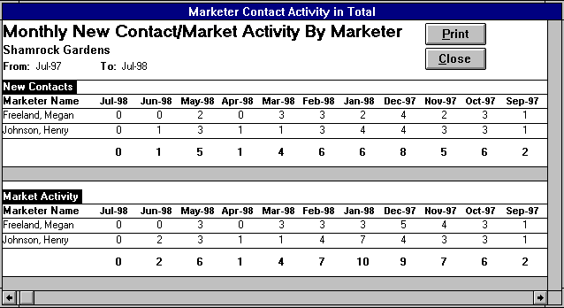

Referral Contacts Detail
This form provides the user with referral activity detail over a specified date range. Specifically the form yields the following information: referral name, company/agency name, referral type, job title, referral city, state, zip, specific source, initial contact date, last contact date, and contact count. This form reveals on an individual referral contact basis, the marketer's efforts to cultivate the referral. This form will show only those referrals who have been contacted during the user specified date range.

Exhibit 49: Referral Contacts Detail

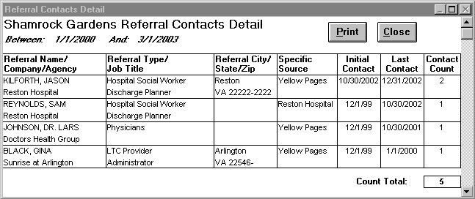

Time To Close Lease By Resident
Select this report to review by each resident the number of days between their initial contact date and lease start date. You can review either for all leases or an user defined date range. You can select your date range either to span initial contact or lease start dates. A resident should never have a negative date difference, since this would mean that the resident’s lease started before they contacted your facility. Furthermore, a blank initial contact date reveals that you have entered no contacts for the given resident lease. You should correct errors you discover through this report in the “Client Contact Information” and “Contact Entry” forms. This form allows the use of the Sort Options Menu.

Exhibit 50: Time to Close Lease By Resident

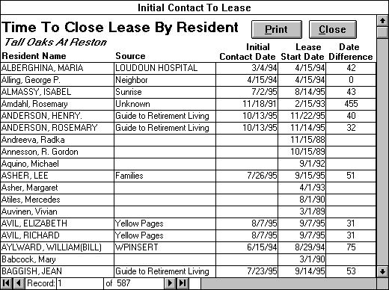

Marketing Budget Report

After clicking this button, the “Marketing Budget Option” box appears. You can choose to either add or edit budget items or to print out the marketing budget report as seen below:

Exhibit 51: Marketing Budget Options

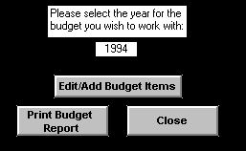

First, you must choose the year of the budget you wish to work with; the current year is the default choice. If you need to add a budget item or change the allocation amounts, click the EDIT/ADD BUDGET ITEMS. Clicking the button will open the “Marketing Budget” form as seen in Exhibit 46.

Exhibit 52: Marketing Budget Form

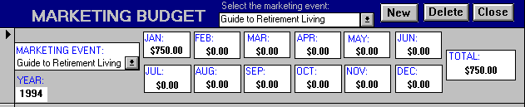

Once you enter this form, you can recall a previous marketing event by using the list box under the heading ‘Select the marketing event.’ You can then enter the appropriate dollar amounts in each of the appropriate months. When you need to add a new event, use the pull down list of sources and select your choice. If the budget item you need to enter is not in the marketing event list, select “Add New/Edit.” Selecting “Add New/Edit” will open the “Add a Source Form”(See Exhibit 12). This form will allow you to enter the missing budget item. (Note: If this budget item is not a source that will generate leads, you must make sure not to check either the “Active Contact Source” or “Active Referral Source” boxes. Reference the “Contact Entry” Form, “Specific Source” section for more detail about the “Add a Source” form.) Each Marketing Event has a year field. The default for this field is the current year; you can alter it as needed. You can now use the mouse to move among the months and record your spending amount. If you are not already in a new record, simply click the NEW button to move to a new record. Entering future expenditures is encouraged because marketing costs are only applied against leads and leases through the current month. If you mistakenly enter a new budget item, click anywhere inside the mistaken entry and then click the DELETE button. When you are finished, click the CLOSE button to return to the "Market Analysis Menu." The “Marketing Budget” form allows the use of the Advanced Options Menu.

If you have not completed any of the key fields in this form, you will be alerted by a stop message. Click OK and correct your mistakes before attempting to exit the form again. If you are able to exit the form without completing the mandatory fields, your record will not be saved. The following fields must be completed before exiting: Marketing event, Year.

Use the PRINT BUDGET REPORT button to print an accurate Marketing Budget Report as of today's date.

Demographic Reports
Click this button to view and print demographic reports from the “Demographic Report Options” form. You can close this form by clicking the CANCEL button, which will return you to the "Market Analysis Menu." By clicking the VIEW REPORT button you can view the report, which you have selected from the list below:

Exhibit 53: Demographic Report Options

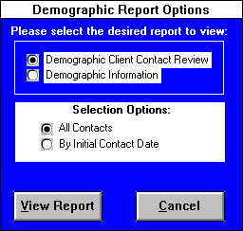

Demographic Client Contact Review
Select this report to review by each potential resident contact the following information: potential resident name, sex, age, living status, health status, care level desired, apartment type desired, and standing. You have the option of reviewing for either for all client contacts or by an initial contact date range. If you chose to view by initial contact date, the initial contact date field will be included on this report. You can edit the following fields within this report: sex, age, living status, health status, care level desired, and apartment type desired. Any changes you make to these fields will be reflected in the “Client Contact Information” form. Click the PRINT button to print this report and the CLOSE button to return to “Demographic Report Options.” This report allows the use of the Sort Options Menu.

Exhibit 54: Demographic Client Contact Review Report

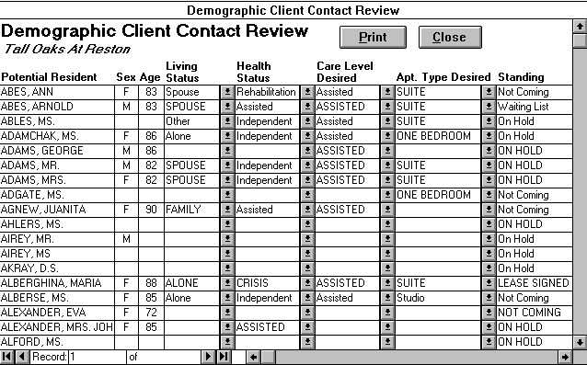

Demographic Information
Select this report to review the number and percentage of potential residents which fall into each of the following categories: standing, current health status, level of care desired, resident sex/age, current living status, and apartment type desired. You have the option of viewing this report for either for all client contacts or across an initial contact date range. Each of the aforementioned demographic categories, except for the standing box, reflects the standing selected in the field at the top of the report. Therefore, you can utilize this report to contrast the demographic profiles of the client contacts who signed leases as opposed to those contacts who decided not to come to your facility. Click the PRINT button to print this report and the CLOSE button to return to “Demographic Report Options.”

Exhibit 55: Demographic Information Report

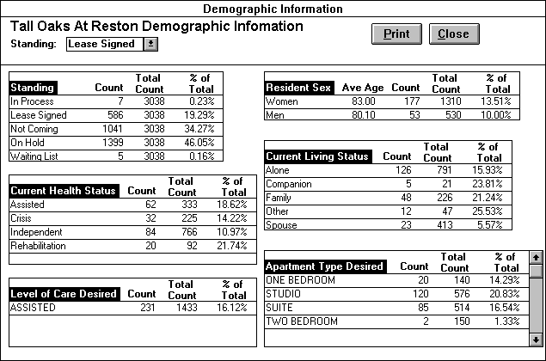

Discharge Reports

Choose this button from the “Market Analysis Menu” to view and print discharge reports from the “Discharge Report Options” form. By clicking the VIEW REPORT button you can view one of the following reports: You can close this form by clicking the CANCEL button, which will return you to the "Market Analysis Menu."

Exhibit 56: Discharge Report Options

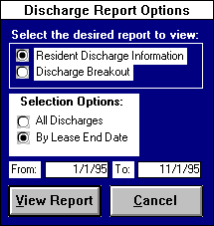

Resident Discharge Information
Select this report to review by each discharged resident lease the following information: resident name, move-out date, lease end date, move-out reason, discharge location, and discharge location type. You have the choice of viewing this report either for all discharges or for discharges occurring over an user specified lease end date range. Furthermore, you can edit the following fields within this report: move-out reason, discharge location, and discharge location type. Clicking the ADDRESS button opens the “Discharge Address” form allowing you to edit or add address information to a for a selected discharge. Selecting a different resident discharge lease on “Resident Discharge Information” will cause the “Discharge Address” form’s information to update to the newly selected discharge. Any changes you make to these fields will be reflected in the “Move-Out” form. Click the PRINT button to print this report and the CLOSE button to return to “Discharge Report Options.” This report allows the use of the Sort Options Menu.
Exhibit 57: Resident Discharge Information

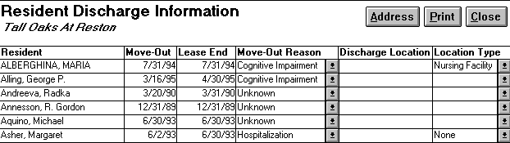

Discharge Breakout
This report creates a chart, which calculates the number of discharges, which occurred for a given move-out reason and discharge location. At the bottom of the report is a pie graph, which indicates the percentage of discharges that were of a given care level on the resident move-out date. You have the choice of viewing this report either for all discharges or for discharges occurring over an user specified lease end date range. Click the PRINT button to print this report and the CLOSE button to return to “Discharge Report Options.” This report allows the use of the Sort Options Menu.
Exhibit 58: Discharge Breakout Report

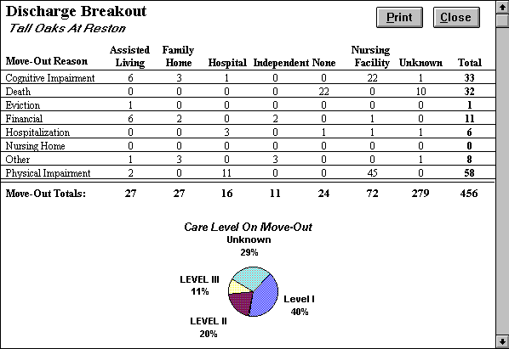

RETURN TO MAIN MENU
If you want to exit Market Leap, click the RETURN TO MAIN MENU button on the “Market Analysis Menu.” You will then see the "Main Menu." If you still want to exit Market Leap, click the button with that heading. If you want to return to a particular menu, click on the button with the menu name, for example to return to “Resident Tracking,” you would click on the RESIDENT TRACKING MENU button. Click RETURN TO MAIN MENU button to exit from the current menu and return to the "Main Menu."

Part V

Resident Tracking Menu

Exhibit 59: Resident Tracking Menu

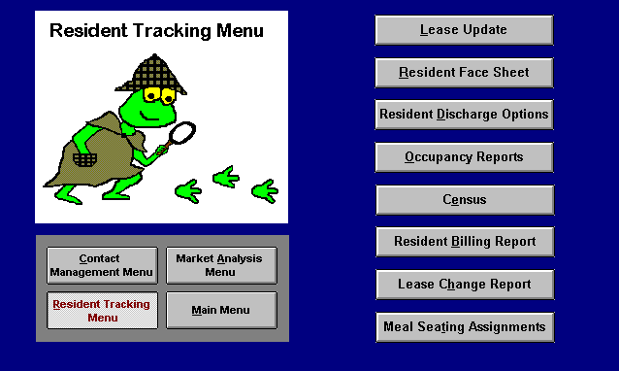

Lease Update

Once you have opened the “Lease” form you can pull up the desired lease record by selecting the appropriate resident name from the ‘Select current resident lease’ list box of current resident leases. Current residents include all residents who are either moved-in or preparing to move into your facility. Residents remain current until they are discharged or as long as their move-out date occurs before the current date. If you wish to select from all residents, click the ALL button. Pressing the ALL button again brings back the current resident list.

If you need to enter a new resident into the lease form, you must do so through the “Client Contact Information” form by clicking on ‘lease signed’ in the standing field for the selected resident. When creating a new resident, you have the option of clicking the RETRIEVE INFO button. This button opens the Retrieve Resident Info dialog box, which allows the user to import data into the current lease from a previous resident's lease by selecting the previous resident's name and pressing the IMPORT button. This feature saves you data entry when you need to create another lease for a resident already in the system. For example, a discharged resident has come back again to live at your facility. The “Lease” form contains the following fields:

Fields

Room Number- The specific room that the resident will occupy.

Room Type - The room’s apartment type is automatically entered when you select the room number.

Lease Start Date- This is the date that the lessee begins responsibility for the rent.

Move-in Date- This is the date that the resident is physically at the property. This date is not necessarily the same as the lease start date.

Furniture in Date- This is the date that the resident's furniture will be moved to your property.

Care Level- Resident classification type, which groups residents according to their service needs. The marketing coordinator should click the appropriate level of care upon admission. If necessary, the level of care should be changed as potential resident status changes.

Rent Payment Type- Click appropriate payment type. Resident payment types are established in the “Software Options” form.

Resident Count - Mark an “x” in this field if the resident’s is leasing only one unit. If a resident is leasing two units, a resident information record should be created for each unit. In this case, this field should be marked on one record, but not the other. This procedure prevents double counting any residents.

Unit Count- Mark an “x” in this field if only one resident is occupying a unit. If more than one resident is sharing an unit, one resident’s lease should be marked with an “x”, while the other one should not. It is up to the user’s discretion to determine which resident information record to mark. This procedure prevents double counting any units.

Resident Birthday- Supply the resident's date of birth here. Please enter four digits for the year.

Resident Phone - Enter the resident’s phone number if applicable.

Contact Party- The person who receives all communication from the property excluding financial correspondence. This person could be the resident, a family member, etc. Please enter in the contact party’s address information, relationship to resident, phone numbers, and legal status.

Person to Bill- If the resident is the Billable Party, select Resident. If the Contact Party receives the bill, select Contact Party. If a person who is neither the Resident nor the Contact Party pays the rent, select Other. You will now be able to complete the name, address, phone numbers, and legal status for this person.

Lease Fields - these fields specify any additional information the facility wishes to track for residents. The facility captures this additional information by creating resident lease fields in the “Resident Lease Field Options” form accessible through the “Facility Options Menu.”

Clicking on the PAGE DOWN button, pages to a second page where more information is captured.

Social Security # - Enter the resident’s social security number.

Medicaid # - Enter the resident’s Medicaid number.

Medicare # - Enter the resident’s Medicare number.

Primary Insurance - Enter the resident primary insurance carrier.

Policy # - Enter the resident’s insurance policy number.

Contact Party #2 Information - A second person to contact in case the first person is unavailable. This person could be a family member, friend, etc. Please enter in the person’s address information, relationship to resident, phone numbers and legal status.

Attending Physician - Enter in resident’s primary physician including address information, phone numbers, and fax number.

Resident Notes - Type in whatever additional information you wish to record about the resident.

Exhibit 60: Lease Form

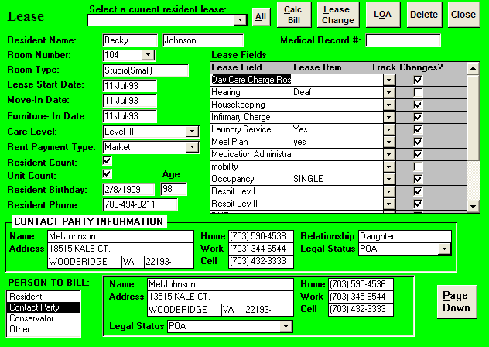

Buttons
At the top of the form is a series of buttons, which enable the marketing associate to perform different resident functions. (If button text is highlighted in gray, this means the button is disabled and the current user does not have permission to perform the given function.) Firstly, clicking on the LOA button, opens the “Leave of Absence” form. Leave of absence refers to any period the resident is physically away from your facility. For example, a resident who has been temporarily admitted to a hospital or leaves for a family vacation is on a leave of absence. The care staff has to track these LOAs through the “Leave of Absence” form. Selecting the DELETE button will delete the current resident record. Only utilize the DELETE to delete erroneous resident records, never use it to discharge a resident. If you wish to calculate the resident’s contract charges for a specific month, select the CALC BILL button to open the “Calculate Bill” form. This form automatically calculates the contract charges for the selected bill month and year. Pressing the LEASE CHANGE button opens the “Lease Change Options” form, which allows the user to track individual lease field, changes.

Lease Change Options

This form allows the marketing associate to record and edit changes to the following list of fields: Room Number, Care Level, Rent Payment Type, and any lease fields the user creates in the “Resident Lease Fields” form and designates change tracking. The NEW CHANGE button opens the “Adding Lease Change” form where the user can add a new change in the resident’s lease. Clicking the EDIT/DELETE button opens a list of all the lease changes that have been made to the lease, which the user is currently editing. Selecting the appropriate lease change from the list opens the form “Edit Lease Change.” This form allows the user to edit or delete a specific lease change. Choosing the VIEW CHANGES button opens the Resident Lease Change form, which lists all the lease changes for the current lease. The CANCEL button closes “Lease Change Options.”

Exhibit 61: Lease Change Options

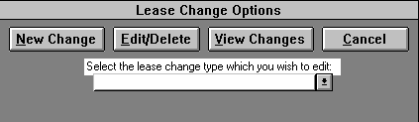

Adding Lease Changes

This form allows the marketing associate to add a lease change to the current lease. The user enters this form through the “Lease Change Options” form by clicking the NEW CHANGE button. If the start date is earlier than or the same as the current date, then the current lease will immediately reflect the lease change after you close this form. If the start date is later than today’s date, the lease change will automatically update on the correct date. Pressing the CANCEL button, allows the user to delete a mistakenly added lease change. The CLOSE button saves the lease change and exits the form.

Resident Name- This field is automatically filled in with the resident’s name of the current lease. Read-only field.

Change Type- Select the type of lease change.

Start Date- The date that the lease change is to take effect.

Lease Item- The specific item to be changed on a lease given a particular change type.
Special Rate - Mark an “X’ in this box, if you wish to bill the specific resident at a different rate than the default rate specified for selected lease item. The marketing coordinator specifies the default rates for care levels, payment types, and room numbers through the “Software Options” form. The marketing coordinator specifies the resident lease field defaults in the “Resident Lease Fields” form.

Special Default Rate Type - The user only completes this field when he/she desires to enter a special rate. The choices are either a daily or monthly rate.

Special Default Rate - The user only completes this field when he/she desires to enter a special rate.

Comment - The user can enter an explanation or any other important information concerning any lease change.

Exhibit 62: Adding Lease Change

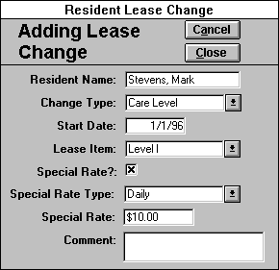

Edit Lease Change

This form allows the user to edit or delete a lease change associated with the current lease. The user enters this form through the “Lease Change Options” form by clicking the EDIT/DELETE button and selecting a lease change from the list.

Resident Name- This field is automatically filled in with the resident’s name of the current lease. Read-only field.

Change Type- The type of lease change. Read-only field.

Start Date- The date that the lease change is to take effect.

Lease Item- The specific item to be changed on a lease given a particular change type. For example, if the change type is Care Level, the lease item would be either Independent, Level I, Level II, or Level III.

Special Rate - Mark an “X’ in this box, if you wish to bill the specific resident at a different rate than the default rate specified for selected lease item. The marketing coordinator specifies the default rates for care levels, payment types, and room numbers through the “Software Options” form. The marketing coordinator specifies the resident lease field defaults in the “Resident Lease Fields” form.

Special Default Rate Type - The user only completes this field when he/she desires to enter a special rate. The choices are either a daily or monthly rate.

Special Default Rate - The user only completes this field when he/she desires to enter a special rate.

Comment - User can enter an explanation or any other important information concerning any lease change.

Pressing the DELETE button, allows the user to delete a mistakenly entered lease change. The CLOSE button saves the edited lease change and exits the form.

Exhibit 63: Edit/Delete Lease Change

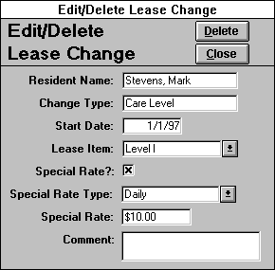

Resident Lease Change

This “read-only” form is simply a listing of all the lease changes associated with the current lease. The user enters this form through the “Lease Change Options” form by clicking the VIEW CHANGES button. Use the PRINT button to print out this form and the CLOSE button to close the form. The “Resident Lease Change” form allows the use of the Advanced Options Menu.

Exhibit 64: Resident Lease Change

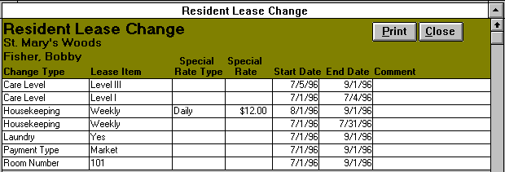

Leave Of Absence

You access this form by clicking the LOA button in the “Lease” form. Leave of absence refers to any period the resident is physically away from your facility excluding a permanent discharge. For example, a resident who has been temporarily admitted to a hospital or who leaves for a family vacation is on a leave of absence. Therefore, the “Leave of Absence” lists each of the specified resident’s LOAs the care staff has tracked. To enter a new LOA, the following fields need to be completed:

Leave Date - The date and time that the resident leaves your facility.

Return Date - The date and time the resident is supposed to return to the facility. If this date is unknown, leave this field blank.

Absence Reason -The reason the resident is leaving the building (select one):
Cognitive impairment- The resident's cognitive care needs exceed the care, which your facility provides, and the resident is seeking treatment out of house.

Physical Impairment- The resident's physical care needs exceed the care that your facility provides and the resident seeks temporary treatment or rehabilitation outside your facility.
Vacation - The resident is leaving your facility for a family visit or vacation.

Other- None of the above reasons correctly describes the reason a resident is leaving your property.

Location Type - The term that best describes where the resident is going on leave:
Assisted Living - A community of the elderly where medication, health, meals and the activities of daily living can be monitored.

Family home - A place where a resident can live with a family member.

Hospital - A medical facility where the sick or injured can receive emergency or intensive care.

Nursing Facility - A facility for the dependent where skilled care or nursing services are provided.

Vacation Site - A place where the resident goes to relax.

Absence location - The name of the place where the resident is staying on leave from your facility.

The user can edit previously entered LOAs, simply by clicking in the desired field and inputting the correct information. If you discover an erroneous record(s), you should delete the incorrect records by clicking on the record selector(s) and clicking the DELETE button or pressing the delete key from the keyboard. Furthermore, the PRINT button will print this form, while selecting the CLOSE button will close “Leave of Absence” and return you to the “Lease” form. The “Leave of Absence” form also allows the use of the Sort Options Menu.

Exhibit 65: Leave of Absence

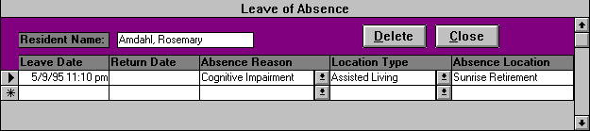

Clicking the CLOSE button will exit this form and return you to the “Resident Tracking Menu.”

Resident Face Sheet

This read-only form produces a face sheet containing the valuable resident data collected through the “Lease” form. (Any changes in information are made through “Lease.”) The face sheet contains the following lease fields: resident, billable party, contact party, contact party #2, attending physician, discharge, and other information. The user can pull up the desired resident record by selecting the appropriate resident name from the ‘Select current resident’ list box of current residents. If you wish to select from residents, click the ALL button. Pressing the ALL button again brings back the current resident list. Once the desired resident record is current, the user can press the PRINT button to print out the resident face sheet. The marketing associate can also utilize the “Resident Lease Field Options” form to select which of the user-created lease fields will be incorporated on the “Resident Face Sheet” form. Select the CLOSE button to return to the “Resident Tracking Menu.”

Resident Discharge Options

Clicking on the RESIDENT DISCHARGE OPTIONS button in the “Resident Tracking Menu” opens the “Resident Discharge Options” form. You use this form to either discharge residents who are leaving your facility or edit the discharge record of residents you have already moved out. To discharge a current resident choose the ‘Discharge resident’ option and then select the resident you desire to move-out from the combination list box. Pressing the VIEW FORM button will open a new discharge record for the selected resident. On the other hand, select the ‘Edit discharge record’ option to edit or delete a resident who has already been move-out. After selecting the desired resident, clicking on the VIEW FORM button opens to the selected resident’s discharge record.

Exhibit 66: Resident Discharge Options

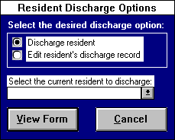

To complete a resident’s discharge record, you need to fill out the following fields:
Fields

Resident Name - The program automatically inputs the resident’s name from the “Resident Discharge Options” form.

Move-Out Date - The date the resident is physically moved out of your facility. If the resident has any LOAs whose leave or return dates are later than this date, the overlapping LOAs will be deleted.

Move-Out reason- This information should be determined by the care staff. Select one of the following:
Cognitive impairment- The resident's cognitive care needs exceed the care, which your facility provides.

Death- The resident died.

Eviction- The resident has been evicted. The facility has processed a Notice to Vacate against a resident's and/ or family's wishes.

Financial- The resident needs to secure different living arrangements due to her financial situation.

Physical Impairment- The resident's physical care needs exceed the care, which your facility provides.

Relocation- The resident is moving because of a change in geographic interest.

Respite- The resident is moving because he/she only wanted a respite stay at your facility.

Other- None of the above reasons correctly describes the reason a resident is moving-out of your property.

Hospitalization- Click this box to indicate that the resident has been discharged to a hospital. A list box of local hospitals will appear. Choose the discharge hospital by pointing and clicking. To add a new hospital to the list, type in the hospital’s name in the list box, press enter, and choose yes at the message prompt.

Location type - Select the term that best describes the resident's new home:
Assisted Living - A community of the elderly where medication, health, meals and the activities of daily living can be monitored.

Family home - A place where a resident can live with a family member.

Hospital - A medical facility where the sick or injured can receive emergency or intensive care.

Independent - A living arrangement where the resident is expected to provide most services for herself.

Nursing Facility - A facility for the dependent where skilled care or nursing services are provided.

None - Option for a resident who is deceased.

Discharge location - The name of the place to which the resident has been discharged. If the resident moved in with her daughter, you would choose ‘Family home’ for location type; for current location, you would type in ‘daughter's house.’

Address - The street number and name of the resident's discharge location.

City - The discharge location city.

State - The discharge location state.

Zip - The discharge location zip code.

Telephone - The area code and telephone number where the discharged resident can be reached.
When you have completed this form, click the CLOSE button and return to “Resident Tracking Menu.” After closing this form, any lease changes due to start after the lease end date are automatically deleted and current lease changes are updated to end on the lease end date. If you press the DELETE button, the discharge record will be deleted, undoing the resident’s discharge and clearing the end dates on the most recent lease changes.

Exhibit 43: Resident Discharge

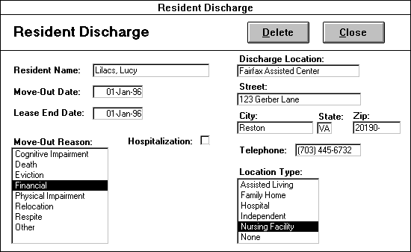

Occupancy Reports

Click this button on the "Resident Tracking Menu" to print or view the "Marketing Status," "Occupancy Status," and/or “Occupancy Status Detail” reports from the "Occupancy Report Options" form. These reports will reflect the date specified. Click the PRINT REPORT button to print the selected report(s) and VIEW REPORT to view them. You can close this form by clicking the CANCEL button, which will return you to the Resident Tracking Menu.

Exhibit 67: Occupancy Reports

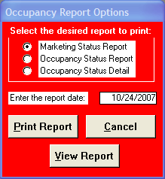

Marketing Status Report

This report can be printed or viewed from the "Occupancy Reports" form for a specified date. The top section of the Marketing Status Report totals data into three general categories: Current Occupancy, Total Occupancy at End of Previous Month Before Move-Outs, and Total Occupancy Effective End of Previous Month. The remainder of the report is divided into eight break-out sections each totaling the number/type of leases calculated. (Note: Only those sections that contain information will print out.) Marketing Status data is organized in the following sections:

Leases Started This Month To Date- Breaks out number of leases by resident name, room/type, care level, payment type, lease start date, and unit count.

Leases-Outs(Occurred This Month to Date)- Breaks out number of leases by resident name, room/type, care level, payment type, lease end date, unit count, discharge location, and move-out reason.

Leases Signed Through 1st Of Next Month(Not Yet Effective)- Breaks out number of leases by resident name, room/type, care level, payment type, lease start date, and unit count.

Leases Ending Effective This Month- Breaks out number of leases by resident name, room/type, care level, payment type, lease end date, unit count, discharge location, and move-out reason.

Probable Leases Through 1st of Next Month- Breaks out number of probable leases by resident name, room/type, care level, payment type, and projected lease start date(established in Client Contact Information form).

Using the summarized data from these sections, the marketing status report will project ”Total Forecast Occupancy For The 1st of Next Month;” this information is highlighted in a shaded bar immediately following the five break-out sections.

Leases Signed Effective After 1st of Next Month- by resident name, room/type, care level, payment type, lease start date, and unit count.

Long-Range Forecast Lease-Ins - Breaks out number of probable leases by resident name, room/type, care level, payment type, and projected lease start date.

Projected Lease Ends- Breaks out number of leases by resident name, room/type, care level, payment type, lease end date, unit count, discharge location, and move-out reason.

Using the summarized data from all eight sections, the marketing status report will project ”Total Forecast Occupancy;” this information is highlighted in a shaded bar at the bottom of the report.

Note that the ‘unit count’ designations “Yes” and “No” for an individual resident record are based on unit census which calculates occupancy in units as opposed to residents. Therefore, when more than one resident occupies a given unit, only one resident in that unit will reflect the unit count designation yes; all other residents in that particular unit will receive the designation “No” and will not be included in the unit count.

Occupancy Status Report

This report can be printed or viewed from the "Occupancy Reports" form. The occupancy status report summarizes occupancy data in three sections: Resident Census Breakout, Total, and occupancy pie graph.

‘Resident Census Breakout’ section breaks out and totals the number of residents at a given care level by payment type and room type.
The following data categories are displayed in the Resident Census Breakout:

Care Levels- Determined by the care needs of a resident, ranging from Level I to III.

Room Type- The type of unit the resident occupies (i.e. Studio, Suite, One Bedroom) Room type is based on and entered through the “Room Plan” form.

Payment Type - The payment classification type for the resident’s rent. Payment type choices are entered through payment types on the “Software Options” form.

Totals - The far right-hand column displaying totals for each care level by ‘payment type’ and/or ‘room type.’

Grand Total- Summarizes the total number of residents currently leasing units.

The ‘Total’ section breaks out room type by the categories ‘Resident Census,’ ‘Unit Census,’ ‘Units,’ and ‘Vacant.’ The resident census number is reflective of the number of residents currently leasing units. The unit census is reflective of the number of units currently occupied. These two numbers do not have to be the same. These numbers can differ when a facility has either one resident occupying multiple units, or multiple residents occupying a single unit. ‘Units’ reflects the total number of units in the facility, while ‘vacant’ reflects the total number of units currently unoccupied. Note that ‘Unit Census’ should never be higher in number than ‘Units’ and the corresponding ‘Vacant’ number should always be positive or zero.

To the right of the Total section is an occupancy-based pie graph depicting the ‘Occupied’ and ‘Unoccupied’ percentage totals.

Occupancy Status Detail

This form, available through the Occupancy Reports form, is a detailed version of the Occupancy Status Report. While the Occupancy Status Report only shows number counts and totals, Occupancy Status Detail includes the resident name, room #, room type, payment type, care level, resident count, and unit count of the residents who actually comprise those totals. You can use the room type, payment type, and care level filters and the Sort Options Menu to filter and sort this form's data respectively. This form should be very helpful in troubleshooting occupancy report and census discrepancies.

Exhibit 68: Occupancy Status Detail

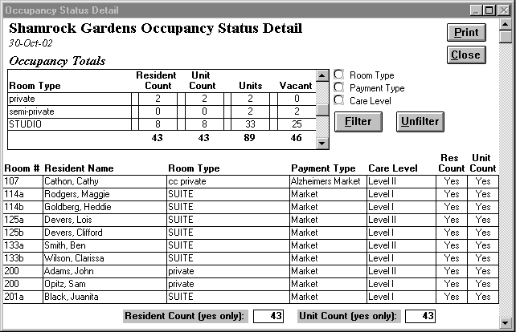

Census

Click this button to print today's resident census. The marketing associate will be able to choose between two types of censuses (physical and detailed) and two types of formats (alphabetical and room number). These censuses are based on the residents who are actually in the building at the moment. They are dependent on the move-in date entered when a lease is signed and the move-out date given when a Notice to Vacate is processed. As long as today’s date is greater than or equal to the move-in date and less than or equal to the move-out date, the resident will appear on the census. Click all the reports that you would like to print and then click the PRINT button. Choose among the following:

Detailed Census By Resident - For an alphabetical listing of residents with the following information: resident name, room number, room type, phone number, payment type, care level, assistance status, occupancy.

Detailed Census By Room # - Same as above, ordered by room number.

Physical Census By Resident- For an alphabetical report of residents with the following information: resident name, room number, phone number(if applicable: meal seating, table assignment, mailbox number).

Physical Census By Room # - Same as above, ordered by room number.

To take advantage of more flexible census reports, click on the ADVANCED USER CENSUS button to reveal the “Advanced User Census” options. Clicking the CANCEL button returns you to the “Resident Tracking Menu.”
Exhibit 69: Census Options

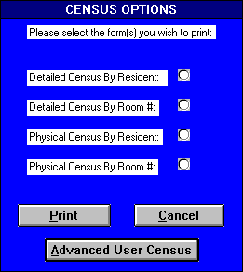

Advanced User Census
Available through the “Advanced User Census,” the “Detailed Census” and the “Physical Census” are based on the residents who are currently in the building. They are dependent on the move-in date entered when a lease is signed and the move-out date given when a Notice to Vacate is processed. As long as today’s date is greater than or equal to the move-in date and less than or equal to the move-out date, the resident will appear on the census. The “Lease Census” and the “Custom Census Creation” are based on all the leases which have a lease start date earlier than today and either no lease end date or one that is later than today. Each of these forms can be viewed by clicking the appropriate button: DETAILED CENSUS, PHYSICAL CENSUS, LEASE CENSUS, CUSTOM LEASE CENSUS, and CUSTOM CLIENT CENSUS . These forms allow the use of the Advanced Options Menu.

The “Advanced User Census” reports contain the following information:

Detailed Census- resident name, room number, room type, phone number, payment type, care level, assistance status, occupancy.

Physical Census- resident name, room number, phone number (if applicable: meal seating, table assignment, mailbox number).

Lease Census- room number, room type, resident name, birth date, nursing profile, occupied unit, lease start date, lease end date.

Custom Lease Census - select from all established lease fields and user-defined lease fields to customize your own census. This advanced user report allows the marketing associate to define a lease field census by adding and removing lease fields pre-determined by the program or user-defined in the “Resident Lease Fields Form.” To create a custom lease census, first click the CUSTOM LEASE CENSUS button. Next, type a descriptive name for your census in the Form Title field. On the left side of the form is a list box entitled ‘Unselected Lease Fields’ containing lease fields to choose from in creating your filter. On the right side of the screen is a list box containing the lease fields, which define your custom census. This list box will appear blank because you have not yet added any new lease fields to the custom census. You can add lease fields to your census in either of two ways. One technique is simply to double click on the desired lease field. Another method is to single click the desired lease field and click the ADD button. Removing services from a filter works similarly. You can either double click the unwanted lease field in the list box or select the lease field and click the REMOVE button. Now you have the additional option of filtering one or a combination of the fields selected for your custom census. For example you could create a custom census of all residents whose physician is Dr. Brown. Further define the census by selecting from resident options: ‘All Residents,’ ‘Current Resident(move dates),’ based on actual move-in, move-out dates and ‘Current Residents(lease dates),’ based on lease start/end dates. You can utilize the custom census option menu located in the upper left-hand corner of your screen to close, print, or sort your custom census.

Custom Client Census - select from all established client contact information fields and user-defined contact fields to customize your own census. This advanced user report allows the marketing associate to define a client contact information census by adding and removing fields pre-determined by the program or user-defined in the "Contact Fields" form. To create a custom client census, first click the CUSTOM CLIENT CENSUS button. Next, type a descriptive name for your census in the Form Title field. On the left side of the form is a list box entitled ‘Unselected Contact Fields’ containing fields to choose from in creating your filter. On the right side of the screen is a list box containing the fields, which define your custom client census. This list box will appear blank because you have not yet added any new lease fields to the custom census. You can add contact fields to your census in either of two ways. One technique is simply to double click on the desired contact field. Another method is to single click the desired field and clicks the ADD button. Removing services from a filter works similarly. You can either double click the unwanted contact field in the list box or select the lease field and click the REMOVE button. Click the CREATE CENSUS button to open the census you have created. You can utilize the custom census option menu located in the upper left-hand corner of your screen to close, print, or sort your custom census.

Exhibit 70: Advanced Census Options

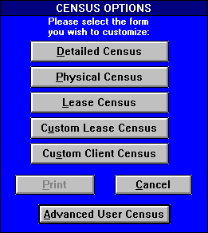

Resident Billing Report
This report allows the marketing associate to review resident billing for a specific month broken out by rent, individual resident, care level, and all other lease fields established as billable items on the Resident Lease Field Options form. (Facility Options Menu). This report automatically calculates billing totals for individual residents as well as for each contract charge category for the selected bill month and year.

To open the report, the user must input the Resident Billing Report date range. Select the Bill Month and Bill Year for which you wish to calculate charges. Once the desired date range is selected, click the VIEW FORM button and a summary report of resident charges will appear. Click CLOSE and the date range selection portion of the Resident Billing Report will close.
The “Resident Billing” Report displays the following fields in addition to all other lease fields designated as billable items:

Resident- Full name listed on the current lease.

Care Level- Standardized resident classification type, which groups residents according to their service needs. Facility Care levels are defined in the Software Options form and selected for an individual resident in the “Lease” form.

Rent- Appropriate payment type. Resident payment types are defined in the Software Options form and selected for a resident in the “Lease” form.

Total- Tallies the individual billing record of each resident for all billable items for the specified time range.

Note that facility-wide totals for each billing category are displayed at the bottom of the form for the specified date range.

Exhibit 71: Resident Billing Report

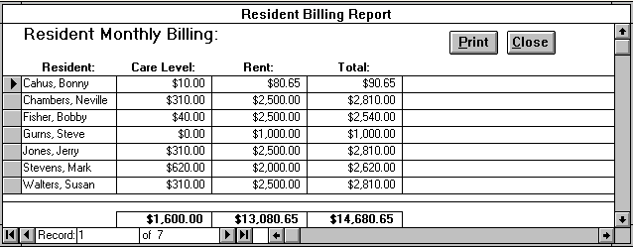

Lease Changes Report
The “Lease Changes Report” form displays the changes made on leases through the “Lease Change Options” form. The records are sorted or filtered in the range specified in the “Lease Change Review.”

Lease Change Review
Lease Change Review provides the information to open the “Lease Changes Report.” The user must input the date range for these lease changes to appear. The user is given two options in filtering the records.

FILTER BY CHANGE DATE button - Displays the Lease Changes Report with records whose Change Date is within the range specified.

FILTER BY START DATE button - Displays the Lease Changes Report with records whose Start Date is within the range specified.

Exhibit 72: Lease Change Review

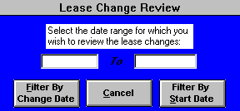

The “Lease Changes Report” is very similar to Resident Lease Change. The report is organized into eight columns:

Resident Name - The resident name on which the lease change is based.

Change Type - The type of lease change.

Lease Item - The specific item to be changed on a lease given particular change type.

Special Rate Type - This field specifies the type of special rate: either daily or monthly.

Special Rate - The rate the specified resident is being charged for the specific lease item. This rate is
“special” because it differs from the default rate specified for selected lease item. The marketing
coordinator specifies the default rates for care levels, payment types, and room numbers through the
Software Options form. The coordinator specifies the resident lease field defaults in the “Resident
Lease Fields” form.

Start Date - This is the start date specified for the change.
End Date - This End date is the calculated date for which the change ends. If End Date is blank, it
means the change still applies.

Change Date - This is the date the lease change is made. This is not necessarily the same as the Start
Date. If the user entered a change on July the first and entered July the 31st for start date, then the
change date will display July the first.

Through the use of filters, the Lease Changes Report allows the marketing associate to single- out data or refine the report based on certain form criteria. To initiate a filter, click on the left of the desired filter section and choose the desired item from the list of choices. Then you can either choose another filter selection to refine your list even more or process the records with the current selection. Pressing the FILTER button reduces the records to the defined filter option selections. Click the UNFILTER button to show all the records again. You select from the following filters located in the upper left-hand side of the form: Resident, Change Type, and Lease Item.
The “Lease Changes Report” form allows the use of the Sort Options Menu. See also the “Lease Change Options” for more information on Lease Changes.

Exhibit 73: Lease Changes Report

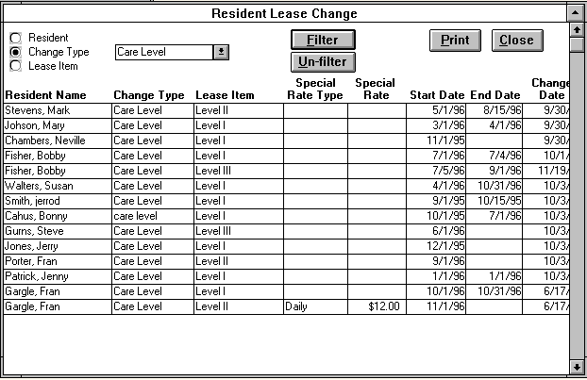

Meal Seating Assignments

This form enables you to assign your current residents to assigned seats at meal times. To assign a resident to an appropriate meal seating, first check the available seating chart located on the right of the form. This chart identifies the number of openings at a given table for a specified seating. Once you have identified a seating and table with an opening, select this choice from the table and seating list box located on the upper left-hand side of this form. This action will update the table seating chart on the left side of the form, which indicates the residents currently assigned to the selected seating and table. This chart also shows each resident’s seat numbers and the empty seats. Your next step would be to replace one of the empty seats with the desired resident selected from the ‘Resident Assigned’ list box. The ‘Resident Assigned’ list box includes all unmoved-out residents and the empty seat option. If your table and seating list box does not include all your facility’s tables and seatings, you can enter these through the “Meal Seating Set-Up” form located on the “Facility Options Menu.”

Exhibit 74: Meal Seating Assignments
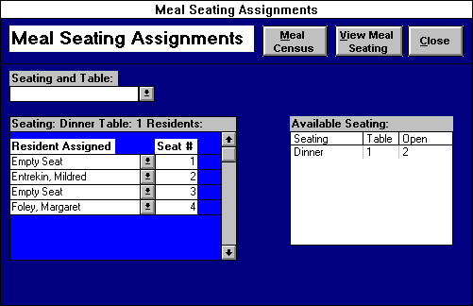

If you wish to review your entire meal seating layout instead of on a individual table and seating basis, click the VIEW MEAL SEATING button to open the “Meal Seating Layout” form. This form allows you to see several tables and seatings at once. You can also choose to make meal assignments through this form by selecting the appropriate resident or ‘empty seat’ in the resident list box. If you wish to print out “Meal Seating Layout” click either the PRINT FORM or PRINT REPORT button. Both selections print the same information, only in slightly different formats. Clicking the CLOSE button returns you to the “Meal Seating Assignments” form. This form allows the use of the Sort Options Menu.

Exhibit 75: Meal Seating Layout

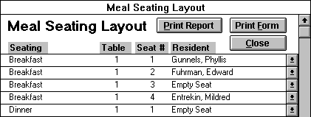

One of the primary goals in creating resident meal assignments is to enable your staff to track resident meal attendance accurately and efficiently. With this goal in mind, the “Meal Census Report” was created. Click on the MEAL CENSUS button to open the “Print Meal Census” form. On this form enter the desired start date and then press PRINT MEAL CENSUS to print the report and return to “Meal Seating Assignments.” This report prints out each meal seating on a separate piece of paper with the following information: seating, table, seat #, room #, resident name, and phone #. The marketing associate can sort the report by resident name or table/seat # by selecting either option. The “Meal Census Report” provides space to record resident meal attendance on a daily basis for a week. The recording of resident meal attendance should simply follow the entry key located at the top of the report. Click the CANCEL to exit this form without printing. Click the CLOSE button to exit “Meal Seating Assignments” and return to the “Resident Tracking Menu.”

RETURN TO MAIN MENU

If you want to exit Market Leap, click the RETURN TO MAIN MENU button on the “Resident Tracking Menu.” You will then see the "Main Menu." If you still want to exit Market Leap, click the button with that heading. If you want to return to a particular menu, click on the button with the menu name, for example to return to “Market Analysis Menu,” you would click on the MARKET ANALYSIS MENU button. Click RETURN TO MAIN MENU button to exit from the current menu and return to the "Main Menu."

PART VI.

Facility Options Menu

Exhibit 76: Facility Options Menu

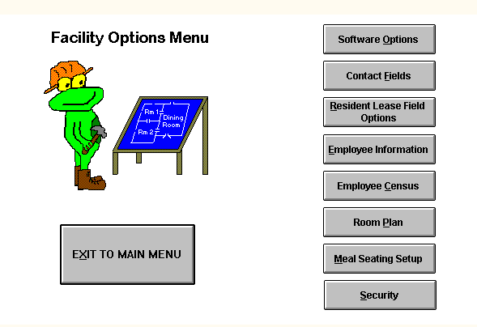

Software Options
This form allows the marketing associate to specify some general options for the Market Leap program. “Software Options” contains the following fields:

Fields

Facility Name/Address - enter your facility’s name, address and telephone number.

Contact Tickle Default Days- enter the default number of days to follow up on a contact for a potential resident. This default number of days will be utilized within the “Contact Entry” form.

Referral Tickle Default Days- enter the default number of days to follow up on a referral contact. This default number of days will be utilized within the “Referral Contact Entry” form.

Care Levels - the different resident classification types that you will utilize to group your residents according to their service needs. Each care level is defined by a time range measured in minutes. The time ranges are set with the amount of weighted service time a resident needs on a daily basis. The marketing coordinator must specify the following information for each care level:

Range Start Time - the minimum amount of service time in minutes a resident requires for a given care level.

Range End Time - the maximum amount of service time in minutes a resident requires for a given care level.

Rate Type - the type of rate that residents will be billed for their care level. The user can choose either a daily or monthly rate.

Rate - the default amount of money that will be billed for a specified care level.

Payment Types - the different payment classification types for resident rent. The user must select a payment basis for each payment type. The payment basis determines if the resident’s rent rate is determined by room type, a flat rate, or a special rate determined for each specific resident. Depending on the payment basis selected, the user may have to enter some or all of the following information: rate type, rate, and room type. The different payment basis and information required for them are listed below:

Room Type - this payment basis requires the user to specify a rate type(daily or monthly) and rate for each type of room for which the coordinator desires to utilize this payment type. The room types available are designated through the “Room Plan” form.
Flat Rate - this payment basis requires the user to specify a rate type(daily or monthly) and rate.

Special Rate - this payment basis requires no additional entry. Residents with a payment type with this payment basis have their billable rent set through the lease change options on the “Lease” form.

Click the CLOSE button to exit this form and return to the “Facility Options Menu.”

Exhibit 77: Software Options

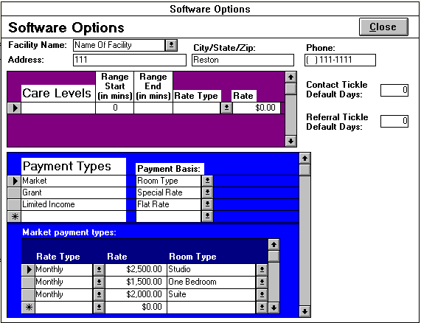

Contact Fields
You utilize this form to specify any additional information you wish to track for your potential residents. You capture this additional information by creating contact fields, which will in turn appear on the “Client Contact Information” form. To enter a new contact field, simply click the ADD NEW button to go to a new record, entering the customized field title and corresponding field choices. To edit an existing contact field, simply click on the ‘select desired contact field’ box, scroll through the list and click on the field you wish to edit. The following fields will appear on the “Contact Field” form:

Fields

Contact Field - Enter the name of the information you wish to capture.

Contact Field Items - Input the list of options the user has to choose from when entering information for the contact field. Some user-defined contact fields such as ‘Secondary Contact Address’ will not have any lease field items since the information collected will be unique for each contact. An example of some contact field items would be Catholic, Protestant, Jewish, Muslim, and Other for the contact field ‘Religion.’

Clicking on the DELETE button will delete the selected contact field. Press the PRINT button to print the Contact Fields Report and the CLOSE button to return to the “Facility Options Menu.”

Exhibit 78: Contact Fields

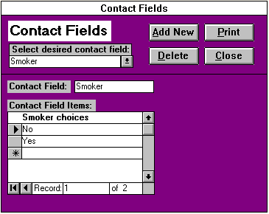

Resident Lease Field Options
This form allows the user either to specify additional lease fields on the “Lease” form or select which of these lease fields will be incorporated on the “Resident Face Sheet” form. The coordinator chooses one of the following options:

Add/Edit Resident Lease Fields - Selecting this option opens the “Resident Lease Fields” form. Through this form user can create new lease fields or edit current lease fields.

Add/Remove Lease Fields on the Resident Face Sheet - Selecting this option opens the “Resident Face Sheet Lease Field Selection” form. The coordinator selects which lease fields he/she wants to be included on the “Resident Face Sheet.”

Exhibit 79: Resident Lease Field Options

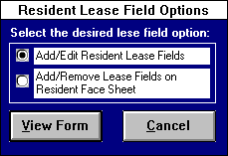

Clicking the VIEW FORM button will open the form associated with the selected option while pressing the CANCEL button returns the care coordinator to the “Facility Options Menu.”

Resident Lease Fields
You utilize this form to specify any additional information you wish to track for your resident. You capture this additional information by creating resident lease fields, which will in turn appear on the “Lease” form. To enter a new resident lease field, simply click the ADD NEW button to go to a new record and enter the appropriate information in the following fields:

Fields

Resident Lease Field - Enter the name of the information you wish to capture.

Resident Field Items - Input the list of options the user has to choose from when entering information for the resident lease field. Some lease fields such as addresses will not have any lease field items since the information collected will be unique for each resident. An example of some lease field items would be Catholic, Protestant, Jewish, Muslim, and Other for the lease field Religion.

Track Changes - Place a “X’ in this box if you wish to track the changes in information for each resident for the selected lease field. The changes are tracked through the “Lease Change Options” form accessed through the “Lease” form.

Billable Item - Place a “X’ in this box if the selected lease field is a billable item for your facility. For the billable item lease fields, the user should supply default rates for each lease item. For billable item lease fields, the lease field changes should always be tracked.

Rate Type - This field only appears if the billable item box is marked with an “X.” The user specifies whether the lease field is billed at a daily or monthly rate.

Active Field - Indicates that a lease field is currently active. The form marks this box with an “X” by default. Only active lease fields are included in the lease field lists in the “Lease” and “Resident Face Sheet Lease Field Selection” forms. When this box is unmarked, a lease field becomes inactive and is dropped from the lists.

Clicking on the DELETE button will delete the selected lease field. (Note: Deactivating the lease field by unmarking the Active lease field is usually the better solution, since you can simply reactivate the field later on if you wish.) Press the PRINT button to print the Lease Fields Report and the CLOSE button to return to the “Facility Options Menu.”

Exhibit 80: Resident Lease Fields

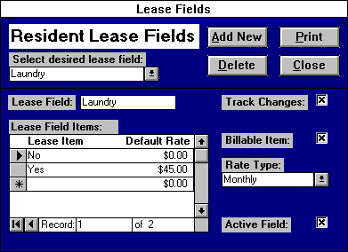

Employee Information

This form allows you to input information concerning the facility’s employees. The employee lists utilized throughout the program are based on the information entered through this form. You can pull up the desired employee record by selecting the appropriate name from the ‘Select current employee’ list box of current employees. Current employees include all staff entered through this form who have either not been terminated or whose termination date occurs after today’s date. If you wish to view a terminated employee’s record, click the OLD button to reveal the ‘Select terminated employee’ list box. Pressing the OLD button again causes the ‘Select current employee’ box to reappear and ‘Select terminated employee’ box to disappear.

Fields

Employee First Name - The employee’s given name.

Employee Last Name - The employee’s surname.

Employee Number - A unique numerical code, which identifies an employee. You cannot give two different employees the same employee number.

Department - A group of employees with a similar set of responsibilities. Examples include Administration, Nursing, Food Service, etc.

Position - The employee’s job title.

Cost Center Code - A numerical code, which indicates the cost center to which the employee’s wages will be charged.

Start Date - The employee’s first day of work for your facility.

Termination Date - The employee’s last day of work for your facility. This field should be blank until you are given notice that an employee is leaving your facility.

Enter Contacts?- Mark an “X” in this box if you wish the employee to be authorized to enter potential resident and referral contacts. The current employees thus designated will appear in the marketer list on the “Contact Entry” and “Referral Contact Entry” forms.

Exhibit 81: Employee Information
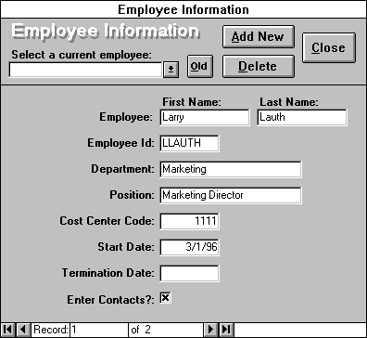
Buttons
At the top of the form is a series of buttons, which enable you to add or delete employees and close this form. Firstly, pressing the ADD NEW button allows you to add a new employee. Before an new employee starts work, you should press this button to create a new, blank employee record. Next, you should fill out the aforementioned fields for the new employee. If you do not add new employees, they will not appear in any of your reports or forms, so this process is crucial.

Selecting the DELETE button will delete the current employee record. Only utilize the DELETE button to remove erroneous employee records such as entering in the same employee twice. Never use it to terminate an employee, enter in the correct termination date instead. Clicking the CLOSE button exits this form and returns you to the “Facility Options Menu.”

Employee Census
Clicking this button opens the current employee census. An employee’s appearance on this census is dependent on his/her start date and termination date. As long as ‘today’s date’ is after or the same as the start date and before or the same as the termination date, the employee will appear on the census. Alternately, if you wish to view and/or edit not only current employees, but also all employees, click the SHOW ALL button. Clicking the SHOW ALL button again will return the census to include only the current employees.

This form lists the same fields as “Employee Information:” employee first name, employee last name, employee number, department, position, cost code, start date, and termination date and ‘enter contacts?’. For users with the appropriate permissions, the DISPLAY WAGE button is shown. Pressing this button, reveals the wage/hr field. This field is security protected because employee compensation is a sensitive matter. Select the PRINT button to print the form and CANCEL to exit and return to the “Facility Options Menu.” The “Employee Census” allows the use of the Advanced Options Menu.

Exhibit 82: Employee Census

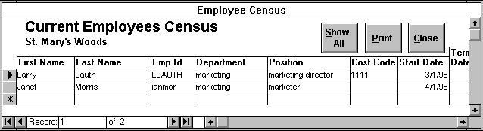

Room Plan

In this form, the marketing associate enters the facility’s room plan. Room Plan is separated into the following three fields:
Fields

Room # - Number of the unit.

Room Type - The type of unit (i.e. Studio, Suite, One Bedroom).

Room Description- Information helpful in marketing a particular room, such as “full bath, close to elevator.”

Clicking the ADD NEW button, sends you to new room record. If you find an incorrectly entered room record, you should delete the record by clicking on the record selector(s) and clicking the DELETE button or pressing the delete key from the keyboard. The PRINT button will print out this form. The CLOSE button will close the form and return you to the “Facility Options Menu.” The “Room Plan” form allows the use of the Advanced Options Menu.

Exhibit 83: Room Plan

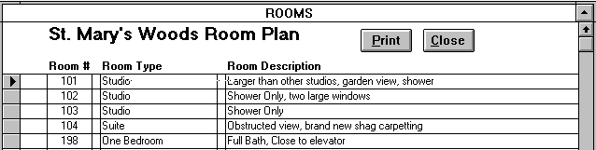

Meal Seating Setup

This form enables you to setup the seatings, tables, and number of seats for your meal seatings so you can create resident meal assignments through the “Meal Seating Assignments” form on the “Resident Tracking Menu.” To add a new table at a seating, click the ADD NEW button to go to a new seating and table record. Type in the name of the new seating and table in the designated boxes. Lastly, enter a seat # for each place at the new table. For example, if the table has three places enter a ‘1’ in the first seat # record, ‘2’ in the next record, and ‘3’ in the next. To go to a particular seating and table for editing or deleting, click on the desired choice from the seating and table list located in the upper left-hand corner of the form. Once the appropriate table and seating record is current, you can click the DELETE button to delete the selected record. To delete only a seat #, select the record selector to the left of the seat # and press the delete key from the keyboard. Conversely, enter the new seat # at the bottom of the seat # list to add a new seat #.

Selecting the EDIT button opens the “Edit Seating and Table” form, which enables you to change the names of the chosen seating and table. Click the UPDATE button to save your changes, CANCEL to undo them and return to “Meal Seating Setup.” Press the CLOSE button to exit “Meal Seating Setup” and return to the “Facility Options Menu.”

Exhibit 84: Meal Seating Setup

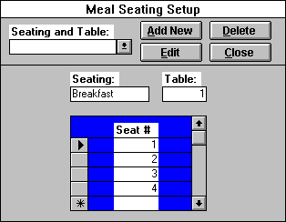

Security Options
This form, accessed through the “Facility Options Menu,” allows the marketing associate to devise Market Leap’s user security. User security determines access in opening Market Leap. A user name and password are required each time the program is opened. Therefore the marketing coordinator has the following security options:

Add New User - Creates a new user account.

Delete User - Deletes a user account.

Clear User Password - Clears a user password in case the password is forgotten.

Change User Password - Allows the coordinator to change an user password.

Set Object Permissions - Enables the coordinator to set user groups’ permissions for viewing Market Leap menu objects.
Exhibit 85: Security Options

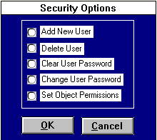

Add New User
The "Add New User" form allows the user that belongs to the coordinators group to create a new user account for a new user. The marketing coordinator must specify the following information:

New User Name - An alphanumeric string that identifies each user account. The User Name is also used in logging into Market Leap.

User Group - Identifies both the type of a user and the permissions granted that user. For example, users who belong to the coordinators group are allowed to create new account and delete old ones, but users that belong to other groups are not allowed to add or delete accounts. The type of access you want to give to a user depends upon the user’s group designation.

Personal Identifier (PID) - A case-sensitive alphanumeric string 4-20 characters long that Market Leap uses to distinguish each user in a Workgroup.

New Password - A case-sensitive alphanumeric string used for logging into the database. Passwords should contain at least five characters and prove easy to remember but difficult to guess. Keeping the password private prevents a security breach and makes tracking much easier.

Verify - Confirms a new password by prompting you to retype the alphanumeric string you have just created.

After the new password is verified, press OK button and the new account will be created. If you decide to cancel creating a new account, press the CANCEL button. After a new account is created, the new user will be able to log-in to the database with the new user name and password.

Exhibit 86: Add New User

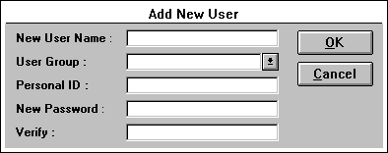

Delete User
"Delete User" allows the users that belong to the marketing coordinator group to delete a user account. You must pick a user name from the list and press the OK button. If you decide not to delete the user, you can press CANCEL. Once a user is deleted, you cannot retrieve it back. But you can create a new user with the same user name.

Exhibit 87: Delete User
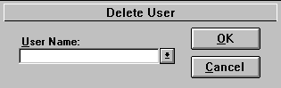

Clear User Password
The "Clear User Password" form enables the users that belong to the marketing coordinator group to clear a user password of a user. This is used in case the user(s) forgot his or her password and wants to regain access to Market Leap. The coordinator can then clear the password through this form and then create a new password for the user through the “Change Password” form.
You must pick a user name from the list and press the CLEAR PASSWORD button. If you decide not to clear the password, you can press CANCEL button. Once the password is cleared, it is important that the user log-in to the database and change his or her password. By reducing the number of no-password accounts, the system maintains a higher level of security.
Exhibit 88: Clear User Password

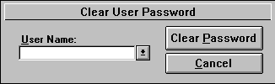

Change User Password
This form allows the marketing coordinator to change a password to a new password for that user account. The user must enter the old password before the user can change the password. In the case of a password cleared through the “Clear User Password” form, you should leave the old password field blank. Text entered in the password text boxes will be replaced with asterisks to conceal the password. The new password must also be verified. Press the OK button and the new password will be asked on the next log-in. Press CANCEL if you decide not to change the user password. Passwords should have at least five characters (letters and/or numbers), which prove easy to remember but difficult to guess.
Use the Change User Password feature as often as you like. If you feel someone has discovered a user password, use the “Change User Password” form. The password is like a key. It is the user's responsibility in keeping that key safe. The password is used along with the user name for logging in to the database. Without the key, the user will not have access.
Exhibit 89: Change User Password

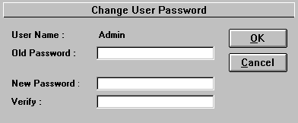

Set Object Permissions
This form allows members of the marketing coordinators group to set object permissions for each menu object. First, you should select the group he/she wishes to set permissions for from the user group list box. This list contains the following user groups: market coordinators, market supervisors, and market staff. Once the appropriate user group is selected, mark an “X” in the permission boxes of those menu objects you want the selected user group to be able to view. Conversely, unmark the permission boxes of those menu objects you do not want the selected user group to view. Marking and unmarking the permission box can be accomplished by clicking in the box with the your mouse. Click the CLOSE button to return to the “Security Options” form.

Exhibit 90: Object Permissions

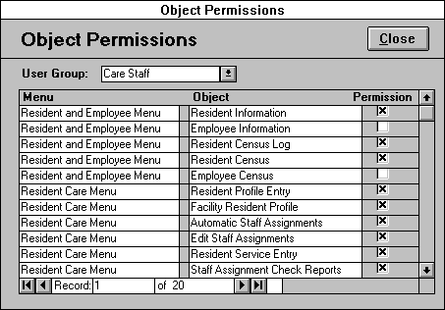

Options Menus
Users can take advantage of the new option menus that are available on most continuous forms (or forms showing a list of records instead of one record at a time). These option menus are located in the upper left portion of the screen and are accessed by clicking once on the menu name. Then the user simply clicks on the menu command he/she wishes to initiate. The two types of menus and their commands are explained below:

Advanced Options

Sort Ascending
This will sort the records of the current field in ascending order. For example, if you have clicked in the follow-up date field in the "Lost Tickler Report" and accessed the Advanced Options Menu and clicked Sort Ascending, the form will display the lost tickler records from earliest to most recent.

Sort Descending
This will sort the records of the current field in descending order. For example, if you have clicked in the follow-up date field in the "Lost Tickler Report" and accessed the Advanced Options Menu and clicked Sort Descending, the form will display the lost tickler records from the most recent to the earliest.

Datasheet View
This will switch the form to datasheet view. Datasheet view displays a form’s information in columns. To select all of a columns and records in a form, click on the small gray box to the left of the first column title. To select a particular column, click on the column title. The user can select multiple columns by clicking the column title and holding the mouse button down while dragging the pointer over the column titles. Release the mouse button when you have selected the desired columns. Another method for selecting multiple columns is by holding down the Shift key and clicking on the column titles of the columns you wish to select. Once a column(s) is selected, the user can move the selected column(s) by clicking on the column title, while holding the mouse button down and dragging the pointer to where he/she wishes to move the column(s). The user also has the option of selecting a record or records by clicking on the record selectors, the small gray boxes to the left of each record. Multiple records can be selected by using either the Shift key or drag and release method. Once the desired data is selected, the user can use the Copy command to copy the data to the Windows Clipboard for use in another application.
Form View
This is the default view of a form. To return to this view from the datasheet one, the user clicks on the Form View command.

Copy
This command will copy the selected text to the Windows clipboard, which can be later retrieved using the Paste command in another Windows application. This command is utilized when the user wants to export selected information to another application. For example, the user can copy the names and room numbers of the residents from the “Detailed Census” form and paste them in an Excel Spreadsheet. To select the data you wish to copy, first switch to datasheet view by clicking the Datasheet View command from the Advanced Options menu.
Then select the data you wish to copy and click the Copy command. (See Datasheet view for data selection tips.) Do not use this command in Form View.

Help
Clicking Help will display the marketing help file, which will open on the topic your cursor rests on. For example you can press the Help command on the Lost Tickler form, and the help file will pop up with information concerning the Lost Tickler. This command does the same thing as pressing F1.

Sort Options

Sort Ascending
This will sort the records of the current field in ascending order. For example, if you have clicked in the follow-up date field in the "Lost Tickler Report" and accessed the Advanced Options Menu and clicked Sort Ascending, the form will display the lost tickler records from earliest to most recent.

Sort Descending
This will sort the records of the current field in descending order. For example, if you have clicked in the follow-up date field in the "Lost Tickler Report" and accessed the Advanced Options Menu and clicked Sort Descending, the form will display the lost tickler records from the most recent to the earliest.

Help
Clicking Help will display the marketing help file, which will open on the topic your cursor rests on. For example you can press the Help command on the “Lost Tickler” form, and the help file will pop up with information concerning the Lost Tickler. This command does the same thing as pressing F1.

Custom Options

Close
This will close the current form.

Print
This prints out the current form.

Sort Ascending
This will sort the records of the current field in ascending order.

Sort Descending
This will sort the records of the current field in descending order.

Help
Clicking Help will display the marketing help file, which will open to the topic on which your cursor rests. This command is the equivalent of pressing F1.

TABLE OF EXHIBITS

Exhibit 1: Contact Tickler Form 7
Exhibit 2: Referral Tickler 8
Exhibit 3: Referral Address 8
Exhibit 4: Buttons 9
Exhibit 5: Main Menu 10
Exhibit 6: Form Color Selections 11
Exhibit 7: Contact Management Menu 12
Exhibit 8: Client Contact Information 13
Exhibit 9: Reason For Not Coming Form 15
Exhibit 10: Waiting List Form 16
Exhibit 11: Contact Entry Form 21
Exhibit 12: Add a Source Form 24
Exhibit 13: Contact Entry Form 27
Exhibit 14: Tickler Review 29
Exhibit 15: Contact Review 30
Exhibit 16: Referrals Form 31
Exhibit 17: Referral Contact Entry 34
Exhibit 18: Lost Tickle Options 37
Exhibit 19: Lost Contact Tickler 37
Exhibit 20: Referral Lost Tickler 38
Exhibit 21: Room Availability Form 39
Exhibit 22: Waiting List Form 41
Exhibit 23: Label Options 41
Exhibit 24: Contact Label Options 42
Exhibit 25: Referral Labels 43
Exhibit 26: Resident Label Options 44
Exhibit 27: Market Analysis Menu 46
Exhibit 28: Marketing Graph Options 47
Exhibit 29: Average Lease-Ins/Lease-Outs Form 48
Exhibit 30: Average New Contacts 49
Exhibit 31: Contact Activity By Standing Form 50
Exhibit 32: Lease-Ins/Lease-Outs Form 51
Exhibit 33: Market Activity By Contact Type Form 52
Exhibit 34: Monthly Census Count 53
Exhibit 35: Monthly Market/Contact Activity 54
Exhibit 36: Monthly Activity By Marketer 55
Exhibit 37: New Referrals By Referral Type 56
Exhibit 38: Reason For Not Coming 57
Exhibit 39: Referral Activity By Contact Type 58
Exhibit 40: Total Contact/Market Activity, New Contacts By Month Graph 59
Exhibit 41: Total Contact/Market Activity, Total Amount of Market Activity By Month 60
Exhibit 42: Total Referral Activity 61
Exhibit 43: Average Time To Close Lease By Source 63
Exhibit 44: Contact/Referral Activity Count 64
Exhibit 45: Cost Per Lead & Lease Form 65
Exhibit 46: General Contact Info 66
Exhibit 47: Sources: Leads and Leases 66
Exhibit 48: Marketer New Contacts/Market Activity 67
Exhibit 49: Referral Contacts Detail 68
Exhibit 50: Time to Close Lease By Resident 69
Exhibit 51: Marketing Budget Options 70
Exhibit 52: Marketing Budget Form 70
Exhibit 53: Demographic Report Options 71
Exhibit 54: Demographic Client Contact Review Report 72
Exhibit 55: Demographic Information Report 73
Exhibit 56: Discharge Report Options 74
Exhibit 57: Resident Discharge Information 75
Exhibit 58: Discharge Breakout Report 75
Exhibit 59: Resident Tracking Menu 77
Exhibit 60: Lease Form 80
Exhibit 61: Lease Change Options 81
Exhibit 62: Adding Lease Change 82
Exhibit 63: Edit/Delete Lease Change 83
Exhibit 64: Resident Lease Change 84
Exhibit 65: Leave of Absence 85
Exhibit 66: Resident Discharge Options 86
Exhibit 67: Occupancy Reports 90
Exhibit 68: Occupancy Status Detail 93
Exhibit 69: Census Options 94
Exhibit 70: Advanced Census Options 96
Exhibit 71: Resident Billing Report 97
Exhibit 72: Lease Change Review 98
Exhibit 73: Lease Changes Report 99
Exhibit 74: Meal Seating Assignments 100
Exhibit 75: Meal Seating Layout 101
Exhibit 76: Facility Options Menu 102
Exhibit 77: Software Options 104
Exhibit 78: Contact Fields 105
Exhibit 79: Resident Lease Field Options 106
Exhibit 80: Resident Lease Fields 107
Exhibit 81: Employee Information 108
Exhibit 82: Employee Census 109
Exhibit 83: Room Plan 110
Exhibit 84: Meal Seating Setup 111
Exhibit 85: Security Options 112
Exhibit 86: Add New User 113
Exhibit 87: Delete User 113
Exhibit 88: Clear User Password 114
Exhibit 89: Change User Password 114
Exhibit 90: Object Permissions 115

